**Chapter 1**

**PREAMBLE**

This preamble is an introductory statement that explains the purpose of the document and its underlying philosophy. Along with the Company Profile, it contains the scope of the system. This includes a Literature Survey along with the Existing System and its limitation. It also comprises of the present development in the form of a problem statement, the objective, its limitations and its advantages.

**1.1 COMPANY PROFILE**

The Indian Space Research Organization (ISRO) is the primary body for space research. Under the guidance of a number of scientists, ISRO has conducted a variety of operations for both Indian and foreign clients. It has several field installations at its disposal and cooperates with the international community as a part of several agreements. India’s space research activities are widely ranked as being efficient and cost effective. Due to its technological achievements which include the Chandrayaan and Mangalyaan projects and its indigenous capabilities, ISRO is now a renowned space agency worldwide. Its vision is to harness space technology for national development, while pursuing space science research and planetary exploration.

The space research activities were initiated in India during the early 1960’s, when applications using satellites were in experimental stages even in the United States. With the live transmission of Tokyo Olympic Games across the Pacific by the American Satellite ‘Syncom-3’ demonstrating the power of communication satellites, Dr. Vikram Sarabhai, the founding father of Indian space programme, quickly recognized the benefits of space technologies for India.

Dr. Sarabhai was convinced and envisioned that the resources in space have the potential to address the real problems of man and society. As Director, Physical Research Laboratory (PRL) located in Ahmedabad, Dr. Sarabhai convened an army of able and brilliant scientists, anthropologists, communicators and social scientists from all corners of the country to spearhead the Indian space programme.



*Fig1.1. Logo of ISRO Satellite Centre*

Since its inception, the Indian space programme has been orchestrated well and had three distinct elements such as, satellites for communication and remote sensing, the space transportation system and application programmes. The INCOSPAR (Indian National Committee for Space Research) was initiated under the leadership of Dr. Sarabhai and Dr. Ramanathan. In 1967, the first ‘Experimental Satellite Communication Earth Station (ESCES)’ located in Ahmedabad was operationalized, which also doubled as a training centre for the Indian as well as International scientists and engineers.

To establish that a satellite system can contribute to the national development, ISRO was clear that it need not wait for its own satellites to begin application development, while foreign satellites could be used in the initial stages. However, before trying out a full-fledged satellite system, some controlled experiment to prove the efficacy of television medium for national development was found necessary. Accordingly, a TV programme on agricultural information to farmers ‘Krishi Darshan’ was started, which received good response.

The next logical step was the Satellite Instructional Television Experiment (SITE), hailed as ‘the largest sociological experiment in the world’ during 1975-76. This experiment benefited around 200,000 people, covering 2400 villages of six states and transmitted development oriented programmes using the American Technology Satellite (ATS-6). The credit of training 50,000 science teachers primary schools in one year goes to SITE.

SITE was followed by the Satellite Telecommunication Experiments Project (STEP), a joint project of ISRO-and Post and Telegraphs Department (P&T) using the Franco-German Symphonie satellite during 1977-79. Conceived as a sequel to SITE which focused on Television, STEP was for telecommunication experiments. STEP was aimed to provide a system test of using geosynchronous satellites for domestic communications, enhance capabilities and experience in the design, manufacture, installation, operation and maintenance of various ground segment facilities and build up requisite indigenous competence for the proposed operational domestic satellite system, INSAT, for the country.

SITE was followed by the ‘Kheda Communications Project (KCP)’, which worked as a field laboratory for need-based and locale specific programme transmission in the Kheda district of Gujarat State. KCP was awarded the UNESCO-IPDC (International Programme for the Development of Communication) award for rural communication efficiency in the 1984.

During this period, the first Indian spacecraft ‘Aryabhata’ was developed and was launched using a Soviet Launcher. Another major landmark was the development of the first launch vehicle SLV-3 with a capability to place 40 kg in Low Earth Orbit (LEO), which had its first successful flight in 1980. Through the SLV-3 programme, competence was built up for the overall vehicle design, mission design, material, hardware fabrication, solid propulsion technology, control power plants, avionics, vehicle integration checkout and launch operations. Development of multi-stage rocket systems with appropriate control and guidance systems to orbit a satellite was a major landmark in our space programme.

In the experimental phase during 80’s, end-to-end capability demonstration was done in the design, development and in-orbit management of space systems together with the associated ground systems for the users. Bhaskara-I & II missions were pioneering steps in the remote sensing area whereas ‘Ariane Passenger Payload Experiment (APPLE)’ became the forerunner for future communication satellite system. Development of the complex Augmented Satellite Launch Vehicle (ASLV), also demonstrated newer technologies like use of strap-on, bulbous heat shield, closed loop guidance and digital autopilot. This paved the way for learning many nuances of launch vehicle design for complex missions, leading the way for realisation of operational launch vehicles such as PSLV and GSLV.

During the operational phase in 90’s, major space infrastructure was created under two broad classes: one for the communication, broadcasting and meteorology through a multi-purpose Indian National Satellite system (INSAT), and the other for Indian Remote Sensing Satellite (IRS) system. The development and operationalisation of Polar Satellite Launch Vehicle (PSLV) and development of Geo-synchronous Satellite Launch Vehicle (GSLV) were significant achievements during this phase.

ISAC at Bangalore is engaged in developing satellite technology and implementation of satellite systems for scientific, technological and application missions. ISAC is functionally organised into five major areas: mechanical systems area including structures, thermal systems and spacecraft mechanisms; digital and communications area including digital systems and communication systems; integration and power area comprising spacecraft checkout, systems integration and power systems; controls and mission area consisting of control system, mission development and computer and information; and facilities. Reliability and components area and program planning and evaluation group provide relevant support to the centre.

Project management teams co-ordinate the implementation of INSAT and IRS projects. Space astronomy and instrumentation division is engaged in space science activities. ISRO Satellite Integration and Test Establishment (ISITE) including a Comprehensive Assembly, Test and Thermo-vacuum Chamber (CATVAC) provide necessary support for qualification of sub-systems and systems to meet the requirements of space environment. Achievements include design and development of more than 50 satellites so far of various types like scientific, communication and remote sensing.

The Computer & Information group (CIG) manages the Central Computing Facility (CCF) of heterogeneous systems like servers and workstations. They are used for hosting application software for the design and analysis of tasks of various satellite sub systems to meet the Research & Development and Project Computing requirements. CIG plays a major role in the planning, design, implementation, administration and maintenance of campus wide LAN at ISAC. It is involved in system software development for in house usage and application software development using Open Source technologies and tools.

The CIG has two divisions, namely, Computer Networks Division (CND) and Central Computer Systems Division (CCSD). The core activities of CCSD are Application Software Support, System and Network Administration, ISACMAIL, Network Management Systems (NMS) and Software Development. The core activities of CND are Network Administration and Maintenance of ISAC LAN, Internet Expansion Activity, Procurement Activities and Database Administration. This project has been completed under the guidance of CND.

**1.2 EXISTING SYSTEMS**

Network connectivity discovery is an extensively studied area, and there are many interesting mechanisms such as ping [1], traceroute [2], DNS [3], address resolution protocol (ARP) [4], and SNMP available to discover network elements and the connectivity among them.

Traceroute [2] is a computer network diagnostic tool for displaying the route (path) and measuring transit delays of packets across an Internet Protocol (IP) network. The history of the route is recorded as the round-trip times of the packets received from each successive host (remote node) in the route (path); the sum of the mean times in each hop indicates the total time spent to establish the connection. Traceroute proceeds unless all sent packets are lost more than twice, then the connection is lost and the route cannot be evaluated. Ping, on the other hand, only computes the final round-trip times from the destination point.

Ping or Packet Internet Gopher [1] is a computer network administration software utility used to test the reachability of a host on an Internet Protocol (IP) network and to measure the round-trip time for messages sent from the originating host to a destination computer. The name comes from active sonar terminology which sends a pulse of sound and listens for the echo to detect objects underwater. Ping operates by sending Internet Control Message Protocol (ICMP) echo request packets to the target host and waiting for an ICMP response. In the process it measures the time from transmission to reception (round-trip time) and records any packet loss. The results of the test are printed in the form of a statistical summary of the response packets received, including the minimum, maximum, and the mean round-trip times, and sometimes the standard deviation of the mean.

The Address Resolution Protocol (ARP) [5] is a telecommunication protocol used for resolution of network layer addresses into link layer addresses, a critical function in multiple-access networks. ARP was defined by RFC 826 in 1982. It is Internet Standard STD 37. It is also the name of the program for manipulating these addresses in most operating systems. ARP is used to convert a network address (e.g. an IPv4 address) to a physical address such as an Ethernet address (also known as a MAC address).

There have been some efforts made by Cisco [6] to standardize the Physical Network Topology Identification and Discovery (PTOPO-MIB) in RFC 2922 [1], however Cisco is the only vendor supporting this. There are various commercial tools such as HP OpenView, IBM’s Tivoli, and AdventNet OpManager but these show only L3 Level switches. Apart from these commercial ventures, there has been much effort made by the research community in this direction.

A good survey and mechanism was proposed to discover network nodes by combining ping, traceroute, SNMP, DNS, and ARP. However, these methods could discover only L3 level switches, though it was proved that SNMP performs better than all other mechanisms [7]. Another mechanism is proposed that is heterogeneous, irrespective of any kind of network, but this mechanism requires ICMP spoofing in order to get complete forwarding table, which is not allowed in most of today’s networks. [3]

**1.2.1 Disadvantages of Existing Systems**

* It is unable to discover a variety of devices simultaneously. These include L2 and L3 switches.
* It fails to provide details of SNMP MIBs required for gathering information.
* The current algorithms such as Ping, Traceroute, DNS, and ASP are time consuming and resource intensive.
* The state of network nodes may change during the discovery process and faulty information may be displayed.
* Current systems do not account for the presence of VLANs in a network. This usually leads to networks with cycles that may interfere with the existing discovery process.
* Existing algorithms are also extensive and complex.

**1.3 PROBLEM STATEMENT**

A wired Local Area Network (LAN) may spread across various buildings and floors for connecting computers and servers. The LAN would normally consist of network switches which are remotely manageable. These networks also exist with different topologies. As the number of network nodes increases, the complexity of monitoring, maintaining and troubleshooting also increases.

With access to information of nodes in a network, network managers are better able to react to and prevent problems. Hence, complete information about the network devices and links is to be maintained for efficient network management.

A comprehensive overview of the network and the nodes attached to it is essential to maintain the network. The knowledge of these nodes allows administrators to anticipate problems and plan for them before services are impacted. To ensure security, isolating the nodes is essential to exactly locate the switch port to which a node is connected.

**1.4 PROPOSED SYSTEM**

**1.4.1 Scope of the System**

The proposed system maps the switch port of the all the nodes and finds information related to the node. It also helps network engineers identify the switch port to which a device is connected and thus eliminates the need of manually tracing the network cables. As the approach of the system is mainly based on Simple Network Management Protocol (SNMP), the Management Information Base (MIB) is analysed and used extensively.

It discovers the devices plugged into each port of a specified switch using Content Addressable Memory (CAM) entries of switches. This is useful for system and network engineers to gain visibility into the IP, MAC, VLAN, status and availability of ports. Since this is a real time discovery and not vendor specific, the administrators can also view the operational status and speed of each port.

**1.4.2 Objective of the System**

* Used to identify the Switch Port to which the node is connected
* Provides an easy and fast mechanism to retrieve information corresponding to the specific node in the network
* To facilitate ease of usage for network administrators to monitor the nodes of a large wired network
* Gives status of the ports, VLANs, switches and nodes within a network
* Contains a comprehensive list of all the nodes that are currently active and inactive
* Provides access only to network administrators

**1.4.3 Features of the Proposed Solution**

* The proposed system is specific to Indian Space Research Organisation’s (ISRO) network
* If the host IP address and the specific MIB required for Community String Indexing are provided for a network, then this solution would be able to retrieve the node status of its network
* The solution is able to obtain information from L2 Switches, L3 Switches and D Link Switches that make up the network as a whole

**1.4.4 Limitations of the Proposed System**

* Is unable to provide the end to end path of a specific connection
* Cannot be implemented on a network that does not completely conform to SNMP standards
* Cannot discern wireless nodes attached to the network
* Does not show the topology of the network

**Chapter 2**

**LITERATURE SURVEY**

* ***Suman Pandey, Mi-Jung Choi, Sung-Joo Lee, James W. Hong*, IP Network Topology Discovery using SNMP, *International Journal of Network Management, Volume 21, Issue 3, pages 169–184, May 2011.***

The algorithm used to implement the system is based on the above paper. It proposes an algorithm which is used to provide details on the SNMP MIBs required for gathering information required for each node. It also gives a solution to handle various types of network devices including L2 and L3 Switches, Routers as well as hosts.

* **Li Zichao, Hu Ziwei, Zhang Geng, Ma Yan, *Ethernet Topology Discovery for Virtual Local Area Networks with Incomplete Information,*  IEEE International Conference on Network Infrastructure and Digital Content, pages 252-260, September 2014.** An algorithm to find the topology of Ethernet networks with incomplete forwarding tables that had been implemented by collecting data through SNMP across many virtual Local Area Networks that are present. As this algorithm is able to handle VLANs as well as Layer 3 switches, it can be used in the proposed system.
* **B. Lowecamp, D. R. O’Hallaron, T. R. Gross, *Topology Discovery for Large Ethernet Networks,* ACM SIGCOMM, August 2001, San Diego, CA, USA, pp 237-248**

This paper provides information on where the algorithm must be implemented such that large networks can be traversed with efficiency and speed. It says that the core operation is determining the port to which each node is connected and that Virtual LANs that exist in a network can be treated as a separate switch. It mentions a forwarding table that is present in each switch that is populated when nodes send and receive messages. Hence, it is dynamic in nature.

* **Bierman, K. Jones, *Physical Topology MIB*, RFC 2922, IETF, September 2000**

This document describes managed objects used for managing physical topology identification and discovery. It showcases the importance of SNMP and its extent of usage as the Internet Engineering Task Force (IETF) has now designated an SNMP MIB to describe topology. However, a protocol to obtain required information is not mentioned in this document.

* **Y. Breitbart, M. Garofalakis, B. Jai, C. Martin, R. Rastogi, A. Silberschatz, *Topology Discovery in Heterogeneous IP Networks: The NetInventory System*, IEEE/ACM Transactions on Networking, Vol. 12, No. 3, June 2004, pp. 401-414.**

This protocol is proposed here where a method of accessing the Management Information Base (MIB) of switches which are attached to the host through their Object Identifiers (OID). Object Identifiers are given by their name and their associated value. This is essential to the proposed system in order to retrieve the relevant information that will later be processed into data.

* **Cisco, *SNMP Community String Indexing,* http://www.cisco.com/warp/public/477/SNMP/camsnmp40367.html.**

This document describes how to use Simple Network Management Protocol (SNMP) community string indexing on switches. Some standard MIBs assume that a particular SNMP entity contains only one instance of the MIB. In these cases, a community string indexing is provided to access each instance of the MIB.

* **E. Decker, P. Langille, A. Rijsinghani, K. McCloghrie, *Bridge MIB*, RFC 1493, July 1993**

This document gives a complete tabulation is given which is a comprehensive overview of managed objects for switches. It defines objects for managing Layer 2 Switches based on IEEE 802.1D-1990 standard in a network. This memo defines a portion of the Management Information Base (MIB) for use with network management protocols in TCP/IP based internet.

* **Cisco, *How to Get Dynamic CAM Entries (CAM Table) for Catalyst Switches Using SNMP*, http://www.cisco.com/en/US/tech/tk648/tk362/technologies_tech_note09186a0080094a9b.shtml.**

Specific objects can be accessed through SNMP Community String Indexing. However, these are specific to BRIDGE-MIB supported switches and have to be modified to the needs of the proposed system. This concept is extensively used in which gets dynamic Content Addressable Memory (CAM) entries for a given switch. This comprises of the nodes attached to the switch and their Media Access Control (MAC) Addresses.

* **Wenyun Zhao , Wu Ren, *An Observer Design-pattern Detection Technique,*  IEEE International Conference on Computer Science and Automation Engineering , 2012, pp. 544-547**

Since the database changes due to expiration of old nodes and learning of new nodes, a timer is required for constantly refreshing the contents of the database. This is implemented on the basis of the above which provides an architectural pattern that effectively allows the timer to be an independent entity that causes the refreshing. The approach for the Observer design pattern is on a Java system.

**Chapter 3**

**THEORETICAL BACKGROUND**

**3.1 OBSERVER PATTERN**

The observer pattern is a [software design pattern](http://en.wikipedia.org/wiki/Design_pattern_(computer_science)) in which an [object](http://en.wikipedia.org/wiki/Object_(computer_science)#Objects_in_object-oriented_programming), called the subject, maintains a list of its dependents, called observers, and notifies them automatically of any state changes, usually by calling one of their [methods](http://en.wikipedia.org/wiki/Method_(computer_science)). Observer pattern is used when there is one-to-many relationship between objects such as if one object is modified, its dependent objects are to be notified automatically.

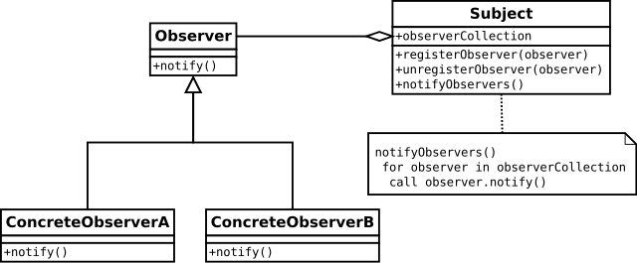

*Fig. 3.1. Basic structure of Observer Pattern*

The subject contains some data that may change over time, and a number of observer objects. An observer depends on the data of the subject in some way. For example, an observer may display the current data values of the subject in a graphical user interface. For efficiency, such an observer may keep a local copy of the data to be displayed, so that it can redraw the display without needing to consult the subject.

**3.2 MODEL VIEW CONTROLLER DESIGN PATTERN**

MVC Pattern stands for Model-View-Controller Pattern. This pattern is used to separate application's concerns.

* **Model** - Model represents an object carrying data. It can also have logic to update controller if its data changes.
* **View** - View represents the visualization of the data that model contains.
* **Controller** - Controller acts on both model and view. It controls the data flow into model object and updates the view whenever data changes. It keeps view and model separate.

The proposed system uses the Model View Controller Pattern in the Struts II Framework. From a high level, Struts2 is a pull-MVC (or MVC2) framework. The Model-View-Controller pattern in Struts2 is realized with following five core components:

* Actions
* Interceptors
* Value Stack / OGNL
* Results / Result types
* View technologies

Struts 2 is slightly different from a traditional MVC framework in that the action takes the role of the model rather than the controller, although there is some overlap. MVC is popular as it isolates the application logic from the user interface layer and supports separation of concerns. Here the Controller receives all requests for the application and then works with the Model to prepare any data needed by the View. The View then uses the data prepared by the Controller to generate a final presentable response. The MVC abstraction can be graphically represented as follows.

The following diagram depicts the Model, View and Controller to the Struts2 high level architecture. The controller is implemented with a Struts2 dispatch servlet filter as well as interceptors, the model is implemented with actions, and the view as a combination of result types and results. The value stack and OGNL provide common thread, linking and enabling integration between the other components.

Apart from the above components, there will be a lot of information that relates to configuration. Configuration for the web application, as well as configuration for actions, interceptors, results, etc.

Based on the following diagram, one can explain the user's request life cycle in Struts 2 as follows:

* User sends a request to the server for requesting for some resource (i.e. pages).
* The FilterDispatcher looks at the request and then determines the appropriate Action.
* Configured interceptors functionalities applies such as validation, file upload etc.
* Selected action is executed to perform the requested operation.
* Again, configured interceptors are applied to do any post-processing if required.
* Finally the result is prepared by the view and returns the result to the user.

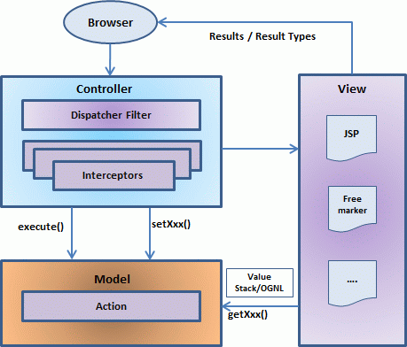

*Fig. 3.2. MVC Architecture of Struts II*

**3.3 SNMP**

Simple Network Management Protocol (SNMP) is an "[Internet-standard protocol](http://en.wikipedia.org/wiki/Internet_protocol_suite) for managing devices on [IP](http://en.wikipedia.org/wiki/Internet_Protocol) networks". Devices that typically support SNMP include routers, switches, servers, workstations, printers, modem racks and more. SNMP is used mostly in [network management systems](http://en.wikipedia.org/wiki/Network_management_systems) to [monitor](http://en.wikipedia.org/wiki/Network_monitoring) network-attached devices for conditions that warrant administrative attention.

SNMP is a component of the [Internet Protocol Suite](http://en.wikipedia.org/wiki/Internet_Protocol_Suite) as defined by the [Internet Engineering Task Force](http://en.wikipedia.org/wiki/Internet_Engineering_Task_Force) (IETF). It consists of a set of [standards](http://en.wikipedia.org/wiki/Technical_standard) for network management, including an [application layer](http://en.wikipedia.org/wiki/Application_layer) [protocol](http://en.wikipedia.org/wiki/Protocol_(computing)), a database [schema](http://en.wikipedia.org/wiki/Logical_schema), and a set of [data objects](http://en.wikipedia.org/wiki/Data_object).

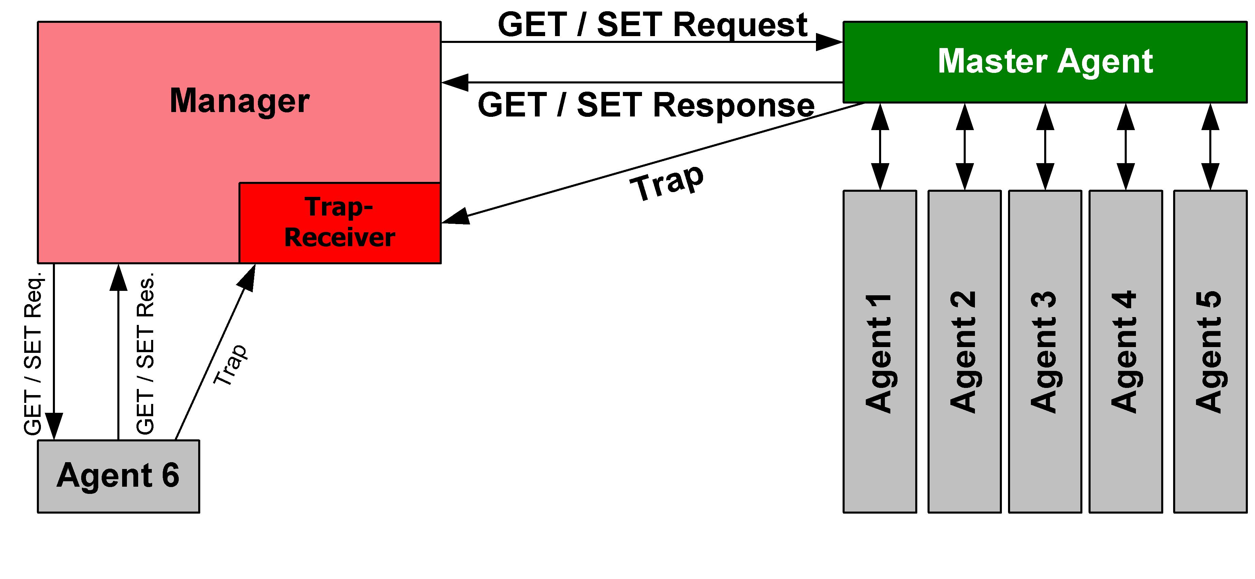

*Fig. 3.3. Principle of SNMP Communication*

An SNMP managed network consists of three key components:

* Managed Device
* Agent — software which runs on managed devices
* Network management station (NMS) — software which runs on the manager

A managed device is a network node that implements an SNMP interface that allows unidirectional (read-only) or bidirectional (read and write) access to node-specific information. Managed devices exchange node-specific information with the NMSs. Sometimes called network elements, the managed devices can be any type of device, including but not limited to routers, access servers, switches, bridges, hubs, IP telephones, IP video cameras, computer hosts, and printers.

An agent is a network-management software module that resides on a managed device. An agent has local knowledge of management information and translates that information to or from an SNMP-specific form.

A network management station (NMS) executes applications that monitor and control managed devices. NMSs provide the bulk of the processing and memory resources required for network management. One or more NMSs may exist on any managed network.

**SNMP Version 2**

The second version of SNMPv2 revises version 1 and includes improvements in the areas of performance, security, confidentiality, and manager-to-manager communications. It introduced GetBulkRequest, an alternative to iterative GetNextRequests for retrieving large amounts of management data in a single request.

However, the new party-based security system in SNMPv2, viewed by many as overly complex, was not widely accepted. This version of SNMP reached the Proposed Standard level of maturity, but was deemed obsoleted by later versions. This version of SNMP is what will be used in the proposed system.

**SNMP Commands**

* GetRequest

A manager-to-agent request to retrieve the value of a variable or list of variables. Desired variables are specified in variable bindings (values are not used). Retrieval of the specified variable values is to be done as an [atomic operation](http://en.wikipedia.org/wiki/Atomic_operation) by the agent. A Response with current values is returned.

* SetRequest

A manager-to-agent request to change the value of a variable or list of variables. Variable bindings are specified in the body of the request. Changes to all specified variables are to be made as an atomic operation by the agent. A Response with (current) new values for the variables is returned.

* GetNextRequest

A manager-to-agent request to discover available variables and their values. Returns a Response with variable binding for the lexicographically next variable in the MIB. The entire MIB of an agent can be walked by iterative application of GetNextRequest starting at OID 0. Rows of a table can be read by specifying column OIDs in the variable bindings of the request.

* GetBulkRequest

Optimized version of GetNextRequest. A manager-to-agent request for multiple iterations of GetNextRequest. Returns a Response with multiple variable bindings walked from the variable binding or bindings in the request. PDU specific non-repeaters and max-repetitions fields are used to control response behaviour. GetBulkRequest was introduced in SNMPv2.

* Response

Returns variable bindings and acknowledgement from agent to manager for GetRequest, SetRequest, GetNextRequest, GetBulkRequest and InformRequest. Error reporting is provided by error-status and error-index fields. Although it was used as a response to both gets and sets, this PDU was called GetResponse in SNMPv1.

* Trap

Asynchronous notification from agent to manager. SNMP traps enable an agent to notify the management station of significant events by way of an unsolicited SNMP message. Includes current sysUpTime value, an OID identifying the type of trap and optional variable bindings. Destination addressing for traps is determined in an application-specific manner typically through trap configuration variables in the MIB.

**Summary**

The proposed system uses a variety of concepts including Observer Design Patterns which are used to program the Timer and Simple Network Management Protocol (SNMP) that forms the crux of the solution. Along with this, Java programming language and Java Drivers (JDBC) are employed to create the solution. It is then deployed using Struts II Framework.

**Chapter 4**

**SYSTEM REQUIREMENT SPECIFICATION**

A Software Requirement Specification describes the behavior of the system being developed. It includes a set of use cases that describe all of the interactions between the user and the software. Use cases are also known as functional requirements.

In addition to use cases, the SRS also contains non-functional or supplementary requirements. Non-functional requirements are requirements which impose constraints on design or implementation such as performance, engineering requirements, quality standards or design constraints.

**4.1 FUNCTIONAL REQUIREMENT**

The functional requirements for a system describe the functionality or services that the system is expected to provide. These depend on the type of software and the type of system that is being developed.

Functional requirements define what a system is supposed to do. The plan for implementing functional requirements is detailed in the system design.

The functional requirements describe the functions to be fulfilled by the system whereas the non-functional requirements describe the overall qualities and attributes of the resulting system. Product requirements specify the characteristics that the software must possess.

The principal non-functional constraints which are relevant to critical systems are reliability, performance, security, usability and safety. The functional requirements for the proposed system are given below:

* Authentication of the user by the system.
* Efficient polling is completed by the manager.
* Consolidated data stored into the database.
* Display required information when MAC address of the node is entered.

**4.2 NON-FUNCTIONAL REQUIREMENTS**

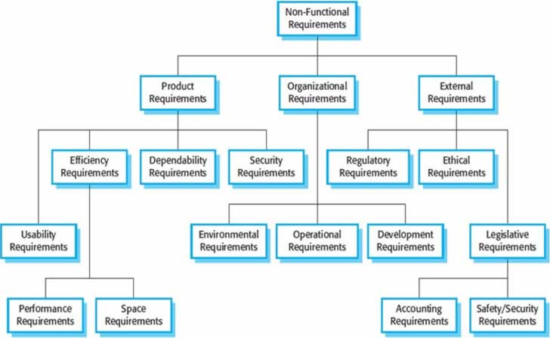

*Fig. 4.1. Types of non-functional requirements*

Non-functional requirements are not directly concerned with the specific functions of the system being developed. They describe the overall behavior and properties such as reliability, response time etc.

Non-functional requirements differ from functional requirements in the following ways:

* They relate to the system as a whole rather than to individual system features.
* They are often more critical than individual use cases.
* Failure to meet individual functional requirement may degrade the system but failure to meet a non-functional requirement my make the whole system unstable.

The non-functional requirements pertaining to the proposed solution are discussed here.

**4.2.1 Product Requirements**

* Usability: A simple user interface created using Struts 2 through which the user must log in and enter the MAC address is implemented
* Performance: The data retrieval for the user will be immediate as the data is already stored in a database.
* Space: Space efficiency is maintained by filtering out the required values using Community String Indexing.
* Portability: As the browser is hosted on a public server, the system will be portable. That is, the user will be able to access from any personal computer with access to the web server.

**4.2.2 Organisational requirements**

* Implementation: The system will be implemented using Java programming language.

**4.2.3 External requirements**

* Privacy: A login authentication has been introduced to maintain limited access to the system.

**4.3 HARDWARE REQUIREMENTS**

*Table 4.1. List of Hardware Requirements*

|  |  |
| --- | --- |
| System | Pentium Dual-Core CPU E5400 2.70GHZ |
| Display monitor | High resolution Color Monitor |
| RAM | 4GB |
| Switches | L2 and L3 switches |

**4.4 SOFTWARE REQUIREMENTS**

*Table 4.2. List of Software Requirements*

|  |  |
| --- | --- |
| Operating System | Windows Operating System |
| Languages used | Java, Structured Query Language, Java Server Pages, CSS, JQuery |
| Tools | Notepad++, Structs II, Ant |
| Libraries | SNMP4J, MySQL Connector |
| Development Environment | Apache Tomcat Application container |

**Summary**

The goal of the software requirement specification is to describe what the proposed software should do. It specifies the needs of the user and client. It establishes the basis for agreement between the client and the server on what the software product will do. It also provides a reference for the validation of the final project.

**Chapter 5**

**SYSTEM ANALYSIS**

System analysis is the study of interacting entities. It is the process of studying a procedure or business to identify the system goals and purposes. Analysis and synthesis always go hand in hand. Synthesis is built on the results of the preceding analysis.

**6.1 FEASIBILITY STUDY**

The feasibility of the project is analyzed in this phase and business proposal is put forth with a very general plan for the project and some cost estimates. During system analysis the feasibility study of the proposed system is to be carried out. This is to ensure that the proposed system is not a burden to the company. For feasibility analysis, some understanding of the major requirements for the system is essential. After the problem is clearly understood and solutions proposed, the next step is to conduct the feasibility study. Many feasibility studies are disillusioning for both users analysts.

Feasibility study is defined as evaluation or analysis of the potential impact of a project or program. The objective is to determine whether the system is feasible. First, the study often pre-supposes that when the feasibility document is being prepared. The analyst is in a position to evaluate solutions. Second, most studies tend to overlook the confusion inherent in system development: the constraints and the assumed attitudes.

The key considerations involved in the feasibility analysis are :

* Economic feasibility
* Technical feasibility
* Social feasibility
* Schedule feasibility
* Operational feasibility

**6.1.1 Economical Feasibility**

This study is carried out to check the economic impact that the system will have on the organization. The amount of fund that the company can pour into the research and development of the system is limited. The expenditures must be justified. The term economic feasibility is used to refer to the financial viability of a given business venture. This is usually a very important study to carry out before starting any business since the main aim of business is profitability. The purpose of the economic feasibility assessment is to determine the positive economic benefits to the organization that the proposed system will provide. It includes quantification and identification of all the benefits expected. This assessment typically involves cost/ benefits analysis.

The system developed was economically feasible because all the software that is required was free of cost and mostly Open Source. The system proposed is to be built on existing hardware i.e. switches and routers as well as the network management system from which the status of the network would be checked. As the network is already existent in ISRO Satellite Centre, the system is economically feasible.

**6.1.2 Technical Feasibility**

This study is carried out to check the technical feasibility, that is, the technical requirements of the system. Any system developed must not have a high demand on the available technical resources. This will lead to high demands on the available technical resources. This will lead to high demands being placed on the client. The developed system must have a modest requirement, as only minimal or null changes are required for implementing this system.

Technical feasibility is the attainability of a system using currently existing technology. Technical feasibility takes into account whether the required technology is available or not and whether the required resources are available in terms of manpower and equipment. The technical feasibility assessment is focused on gaining an understanding of the present technical resources of the organization and their applicability to the expected needs of the proposed system. It is an evaluation of the hardware and software and how it meets the need of the proposed system.

The system in terms of hardware required a computer with any basic operating system. It requires a server in order to host its website. As the system is implemented in ISRO Satellite Centre, their server itself can be used to implement the proposed system. As it aims to solve problems related to network and its status, and active network which is managed by Simple Network Management Protocol (SNMP) is also necessary which is found in the ISRO Network.

In terms of software, Java which able to interface with apache and MySQL through .jar files is optimal for the proposed system. It is coded using Notepad++ and implemented using Struts. A web browser such as Google Chrome or Mozilla Firefox is necessary to access the webpage created.

**6.1.3 Social Feasibility**

The aspect of study is to check the level of acceptance of the system by the user. This includes the process of training the user to use the system efficiently. The user must not feel threatened by the system; instead he/she must accept it as a necessity. The level of acceptance by the users solely depends on the methods that are employed to educate the user about the system and to make him/her familiar with it. The level of confidence must be raised so that some constructive criticism can be made, which is welcomed, as he/she is the final user of the system.

The users in the proposed system are the network administrators of ISRO Satellite Centre, one of whom is an advisor for the implementation.

**6.1.4 Schedule Feasibility**

A project will fail if it takes too long to be completed before it is useful. Typically this means estimating how long the system will take to develop, and if it can be completed in a given time period using some methods like payback period. Schedule feasibility is a measure of how reasonable the project timetable is. Some projects are initiated with specific deadlines. It is necessary to determine whether the deadlines are mandatory or desirable.

**6.1.5 Operational Feasibility**

Operational feasibility is a measure of how well a proposed system solves the problems, and takes advantage of the opportunities identified during scope definition and how it satisfies the requirements identified in the requirements analysis phase of system development.

The operational feasibility assessment focuses on the degree to which the proposed development projects fits in with the existing business environment and objectives with regard to development schedule, delivery date, corporate culture, and existing business processes.

To ensure success, desired operational outcomes must be imparted during design and development. These include such design-dependent parameters such as reliability, maintainability, supportability, usability, producability, disposability, sustainability, affordability and others. These parameters are required to be considered at the early stages of design if desired operational behaviors are to be realized. A system design and development requires appropriate and timely application of engineering and management efforts to meet the previously mentioned parameters. A system may serve its intended purpose most effectively when its technical and operating characteristics are engineered into the design. Therefore operational feasibility is a critical aspect of systems engineering that needs to be an integral part of the early design phases.

**Summary**

Feasibility study makes an assessment of the practicality of the proposed plan or method. It takes into account a number of important criteria that need to be kept in mind before commencing the development of the project. The extent to which the project is feasible has been observed in terms of economic, technical, social, schedule and operational aspects. All these features were individually and collectively analysed and a conclusion was drawn that the feasibility for all the factors in the project was well within the stipulated reach.

**Chapter 6**

**SYSTEM DESIGN**

**6.1 SYSTEM DEVELOPMENT METHODOLOGY**

Systems design is the process of defining the architecture, components, modules, interfaces, and data for a system to satisfy specified requirements. Object-oriented analysis and design methods are becoming the most widely used methods for computer systems design. The UML has become the standard language in object-oriented analysis and design. It is widely used for modeling software systems and is increasingly used for high designing non-software systems and organizations.

A system architecture or systems architecture is the conceptual model that defines the structure, behaviour, and more views of a system. System architecture can comprise system components, the externally visible properties of those components, the relationships (e.g. the behaviour) between them. It can provide a plan from which products can be procured, and systems developed, that will work together to implement the overall system.

**6.2 SYSTEM DESIGN METHODOLGY**

The architectural design of a system emphasizes on the design of the [systems architecture](http://en.wikipedia.org/wiki/Systems_architecture) which describes the [structure](http://en.wikipedia.org/wiki/Structure), [behavior](http://en.wikipedia.org/wiki/Behavior), and more [views](http://en.wikipedia.org/wiki/View_model) of that system and analysis. It is a type of a [scale model](http://en.wikipedia.org/wiki/Scale_model), tangible (also called sometimes physical) representation of a structure built to study aspects of an [architectural design](http://en.wikipedia.org/wiki/Architecture) or to communicate design ideas to clients, committees, and the general public. Architectural models are a tool which may be used for show, presentation, fundraising, obtaining permits, and sale purposes.

Architectural designs are used for a range of purposes -

* Quick, [ad hoc](http://en.wikipedia.org/wiki/Ad_hoc) designs are sometimes made to study the interaction of volumes, or to get an idea of how they look from different angles. Designing a building using rough models can be a very open-ended and practical method of exploring ideas.
* They are an efficient method for exhibiting and selling a design. An architect may employ small-scale physical models, or digital computer models, to help explain the ideas.
* A model may be useful in explaining a complicated or unusual design to the building team, or as a focus for discussion between the design teams such as architects, engineers and town planners.
* Models are also used as show pieces, for instance as a feature in the reception of a prestigious building, or as part of a museum exhibition (for example scale replicas of historical buildings).

For the development of the system, the waterfall model is used. The waterfall model is a sequential development approach in which the development is seen as flowing steadily downwards (Like the waterfall) through the phases of requirements, analysis, design, implementation, testing, integration and maintenance.

The basic principles are:

* The project is divided into phases with some overlap and splash back acceptable.
* Emphasis is on planning, time schedules, target dates, budgets and implementation of an entire system at one time.
* Tight control is maintained over the life of a project via extensive documentation, formal reviews, and approval/sign off by user, information technology management occurring at the end of most phases before beginning the next phase.

**6.2.1 Model Phases**

In the waterfall model, the following phases are in the order:

* Requirements specification resulting in product requirements document.
* Design resulting in software architecture.
* Construction resulting in actual software
* Integration
* Testing and debugging
* Installation
* Maintenance

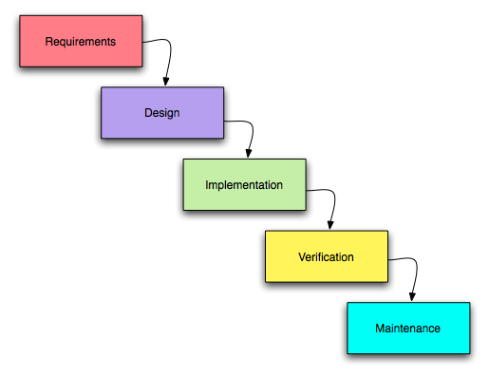Thus the waterfall model maintains that one should move to a phase only when the preceding phase is reviewed and verified.

*Fig 6.1 Waterfall Model Phases*

**6.2.2 Reason for choosing Waterfall Model as Development Method**

The waterfall model is an appropriate method of development when the following are met:

* Requirements are very well known, clear and fixed.
* Product definition is stable.
* Technology is understood
* There are no ambiguous requirements.
* Ample resources with the required expertise are available freely.
* The project is short.
* The advantages of waterfall model are,
* Simple and easy to understand
* Easy to manage due to rigidity of the model
* Phases are processed and completed one at a time.
* Works well for smaller projects where requirements are very well understood.

**6.3 ARCHITECTURAL DESIGN**

**6.3.1 Software Architecture**

The Software Architecture of the proposed system is in the form of a Component Diagram. Component diagrams are different in terms of nature and behaviour. Component diagrams are used to model physical aspects of a system. Physical aspects are the elements like executables, libraries, files, documents etc. which resides in a node.

Component diagram is a special kind of diagram in UML. It does not describe the functionality of the system but it describes the components used to make those functionalities.

So from that point component diagrams are used to visualize the physical components in a system. These components are libraries, packages, files etc. Component diagrams can also be described as a static implementation view of a system. Static implementation represents the organization of the components at a particular moment.

A single component diagram cannot represent the entire system but a collection of diagrams are used to represent the whole. So the purpose of the component diagram can be summarized as:

* Visualize the components of a system.
* Construct executables by using forward and reverse engineering.
* 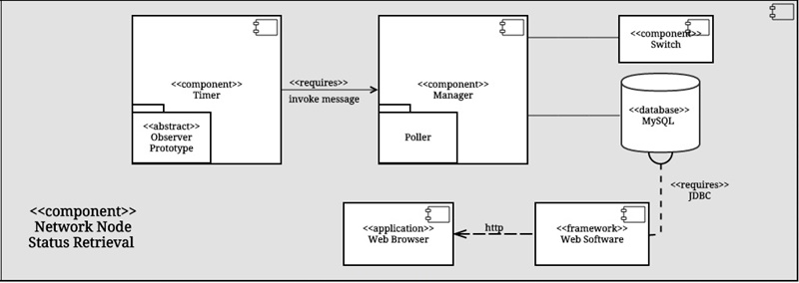Describe the organization and relationships of the components.

*Fig. 6.2. Component Diagram*

**6.3.2 Hardware Architecture**

Hardware architecture refers to the identification of a system's physical components and their interrelationships. In this system, the hardware components include Network Management Systems (NMS), Database Servers and an Apache Tomcat server as well.

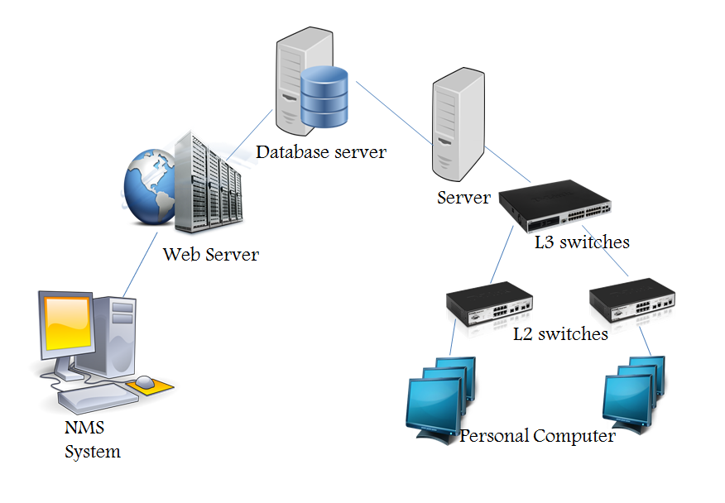

*Fig. 6.3. Hardware Architecture of System*

The end point of the architecture is a Management System from which a Network Administrator can observe the status of the node. The data is taken from the Layer 2 Switches through a Polling at the switch which provides the required data of all the Personal Computers that are attached to it. The Layer 2 Switches are then attached to a Layer 3 Switch which is not traversed to the system. These are attached to the Host Server.

The NMS is hosted on a Web Server which in this case is through an Apache Tomcat Contaner. The data is populated into a Database Server which is accessed by the NMS through a Web Server. This data is the information on the node that the network administrator wants to retieve. This may be related to a port, switch, VLAN or a computer itself within the network that has been analysed.

**6.3.3 System Architecture**

The System Architecture is shown in terms of a flowchart. A flowchart is a type of diagram that represents an algorithm, workflow or process, showing the steps as boxes of various kinds, and their order by connecting them with arrows.

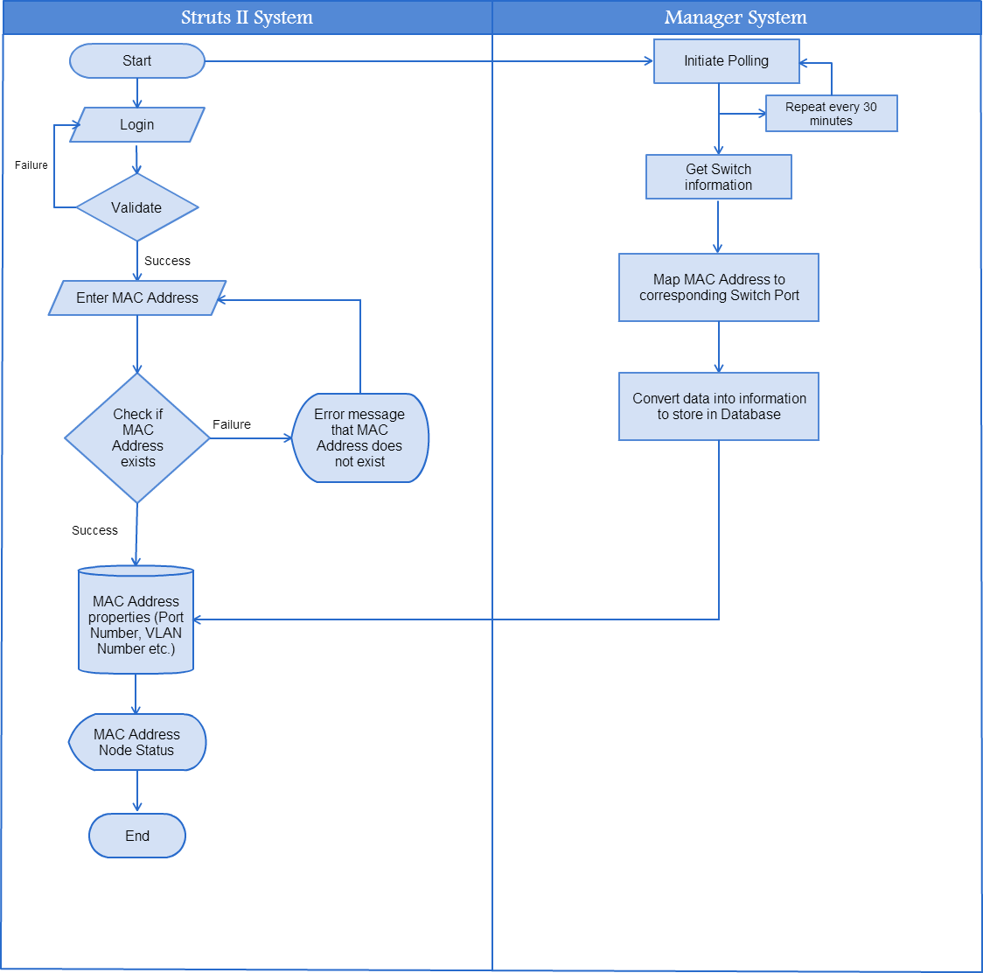

*Fig. 6.4. Flowchart of System*

**6.4 UML DIAGRAMS**

**6.4.1 Use Case Diagram**

A use case diagram at its simplest is a representation of a user's interaction with the system that shows the relationship between the user and the different [use cases](http://en.wikipedia.org/wiki/Use_Case) in which the user is involved. A use case diagram can identify the different types of users of a system and the different use cases and will often be accompanied by other types of diagrams as well. Use case diagrams are usually referred to as [behavior diagrams](http://www.uml-diagrams.org/uml-25-diagrams.html#behavior-diagram) used to describe a set of actions ([use cases](http://www.uml-diagrams.org/use-case.html)) that some system or systems ([subject](http://www.uml-diagrams.org/use-case-subject.html)) should or can perform in collaboration with one or more external users of the system ([actors](http://www.uml-diagrams.org/use-case-actor.html)). Each use case should provide some observable and valuable result to the actors or other stakeholders of the system.

Use case diagrams are in fact twofold - they are both [behavior diagrams](http://www.uml-diagrams.org/uml-25-diagrams.html#behavior-diagram), because they describe behavior of the system, and they are also [structure diagrams](http://www.uml-diagrams.org/uml-25-diagrams.html#structure-diagram)- as a special case of class diagrams where classifiers are restricted to be either [actors](http://www.uml-diagrams.org/use-case-actor.html) or [use cases](http://www.uml-diagrams.org/use-case.html) related to each other with [associations](http://www.uml-diagrams.org/association.html).

As the diagram shows, there are six use cases uses and two actors. The six use cases are:

* Login
* Initiate Timer
* Retrieve Switch Information
* Get information from Switch CAM table
* Convert MAC to IP
* Process data to information and store

**Use Case: Login**

Summary: The user logins into the system using a valid username and password.

Actors: User (System Administrator)

Preconditions: User should login with a valid username and matching corresponding password.

Description: The program execution is initiated by a successful login made by the user giving a valid username and password. The first login will initiate the timer and triggers a poll action.

Exception: Login is unsuccessful when either username or password is invalid or they do not match.

Post conditions: Timer is initiated and the system is ready to poll information.

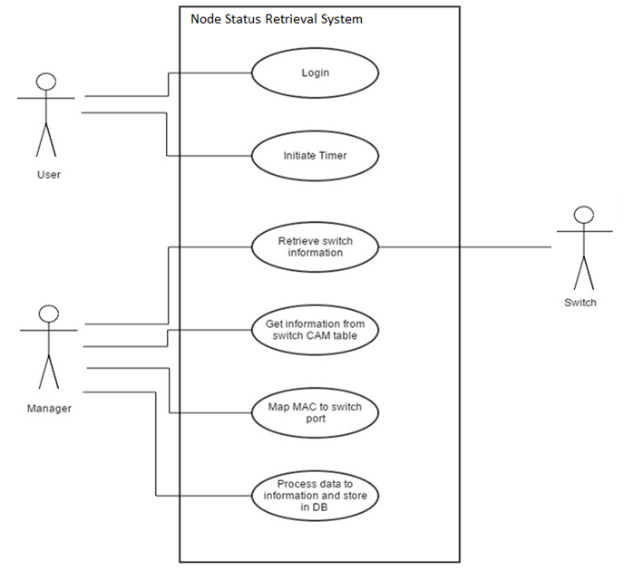

*Fig. 6.5. Use Case Model*

**Use Case: Initiate Timer**

Summary: The timer is set to trigger a signal every 30 minutes.

Actors: User

Preconditions: Initially the system is waiting for a successful login.

Description: The first time the user logins, the timer is initiated and is set to trigger a poll every 30 minutes.

Exception: Authentication failed.

Post conditions: The timer is set to trigger a signal every 30 minutes.

**Use Case: Retrieve Switch information**

Summary: The manager sets and verifies the current switch information that can be accessed later while polling.

Actors: Manager

Preconditions: Once configured information is used later during polling.

Description: While polling the manager obtains the status and relevant information about the switches. For this, initially the switch needs to be configured.

Exception: Cannot access switch information.

Post conditions: Configured information used during polling.

**Use Case: Get information from Switch CAM table**

Summary: Polling action will cause information from the switch CAM table to be read.

Actors: Manager

Preconditions: Information polled and available in the CAM table.

Description: When a polling action occurs, relevant information about nodes in the form of their MAC address is stored in the switch CAM table. This information is red by the manager for further processing.

Exception: *Switch CAM table not initialized*: An error while polling will result in incomplete or incorrect CAM table entries.

*Switch CAM table cannot be accessed*: Due to broken link, the switch and its CAM table may not be accessible.

*Timeout*: When the time taken to retrieve information exceeds a specified time, a timeout error occurs.

Post conditions: Information in CAM table which is in the form of MAC addresses is read by the manager and mapped to its corresponding switch port.

**Use Case: Map MAC to switch port**

Summary: The MAC address stored in the CAM table is processed and mapped to their corresponding Switch port.

Actors: Manager

Preconditions: Complete CAM table entries available.

Description: The manager reads information stored in the CAM table. This information is in the form of MAC addresses. This information needs to be mapped to their corresponding switch ports.

Exception: *Incorrect mapping of entries*: Incorrect or incomplete CAM table entries will cause and error while mapping MAC addresses to their switch ports.

Post conditions: The system is ready to store the information in the database that can be retrieved by the user.

**Use Case: Process data to information and store in database**

Summary: The information obtained after mapping CAM table entries to switch ports needs to be processed before storing in the database.

Actors: Manager

Preconditions: All tables to store port numbers, VLANS are existing and available.

Description: CAM table entries are mapped to their corresponding switch ports. This information is processed and stored in databases depending on the ports and VLANS.

Exception: *Cannot process data*: When the mapped data is incorrect, the processing is altered.

*Cannot store information*: When the table are not available to store information.

Post conditions: Information stored in the database can be retrieved and displayed to the user

**6.4.2 Activity Diagram**

Activity diagrams are graphical representations of [workflows](http://en.wikipedia.org/wiki/Workflow) of stepwise activities and actions with support for choice, iteration and concurrency. In the [Unified Modeling Language](http://en.wikipedia.org/wiki/Unified_Modeling_Language), activity diagrams are intended to model both computational and organizational processes (i.e. workflows). Activity diagrams show the overall flow of control.

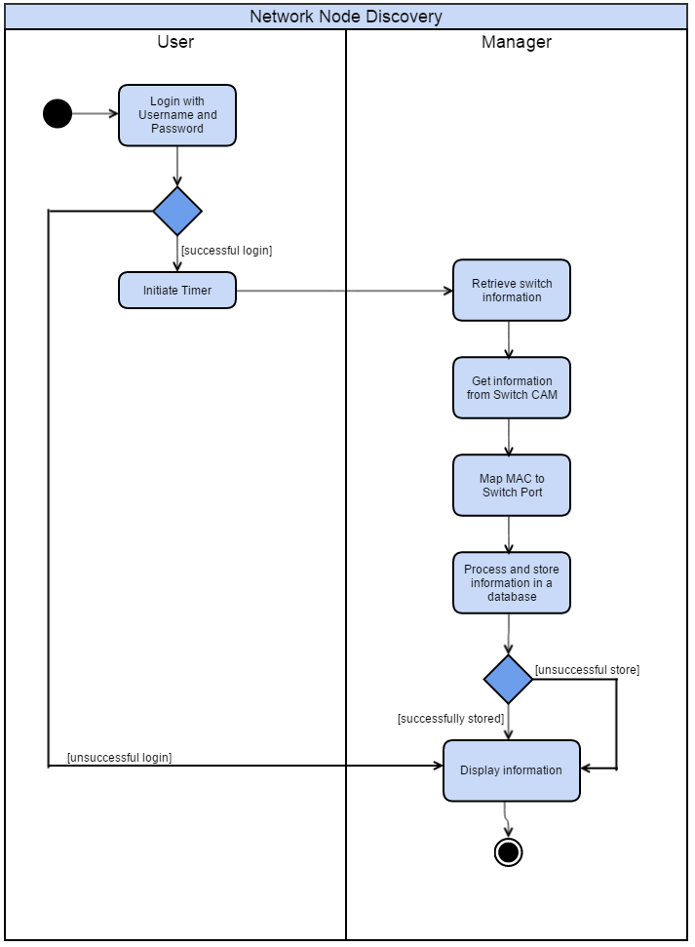

*Fig. 6.6. Activity Diagram*

**6.4.3 State Diagram**

The state diagram in the Unified Modeling Language is essentially a Harel state chart with standardized notationwhich can describe many systems, from computer programs to business processes. In UML 2 the name has been changed to State Machine Diagram. The following are the basic notational elements that can be used to make up a diagram:

* Filled circle, pointing to the initial state
* Hollow circle containing a smaller filled circle, indicating the final state (if any)
* Rounded rectangle, denoting a state. Top of the rectangle contains a name of the state. Can contain a horizontal line in the middle, below which the activities that are done in that state are indicated
* Arrow, denoting transition. The name of the event (if any) causing this transition labels the arrow body. A guard expression may be added before a "/" and enclosed in square-brackets, denoting that this expression must be true for the transition to take place. If an action is performed during this transition, it is added to the label following a "/".
* Thick horizontal line with either x>1 lines entering and 1 line leaving or 1 line entering and x>1 lines leaving. These denote join/fork, respectively.

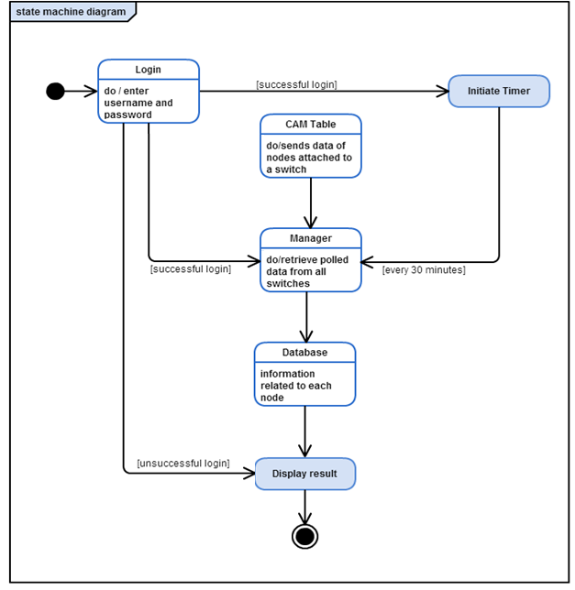*Fig. 6.7. State Diagram*

**6.4.4 Sequence Diagram**

A sequence diagram is an [interaction diagram](http://en.wikipedia.org/wiki/Interaction_diagram) that shows how processes operate with one another and what is their order. It is a construct of a [Message Sequence Chart](http://en.wikipedia.org/wiki/Message_Sequence_Chart). A sequence diagram shows object interactions arranged in time sequence. It depicts the objects and classes involved in the scenario and the sequence of messages exchanged between the objects needed to carry out the functionality of the scenario.

Sequence diagram is the most common kind of [interaction diagram](http://www.uml-diagrams.org/uml-25-diagrams.html#interaction-diagram), which focuses on the [message](http://www.uml-diagrams.org/sequence-diagrams.html#message) interchange among a number of [lifelines](http://www.uml-diagrams.org/sequence-diagrams.html#lifeline). A sequence diagram describes an interaction by focusing on the sequence of messages that are exchanged, along with their corresponding occurrence specifications on the lifelines.

The following nodes and edges are typically drawn in a UML sequence diagram: [lifeline](http://www.uml-diagrams.org/sequence-diagrams.html#lifeline), [execution specification](http://www.uml-diagrams.org/sequence-diagrams.html#execution), [message](http://www.uml-diagrams.org/sequence-diagrams.html#message), [combined fragment](http://www.uml-diagrams.org/sequence-diagrams-combined-fragment.html), [interaction use](http://www.uml-diagrams.org/sequence-diagrams.html#interaction-use), [state invariant](http://www.uml-diagrams.org/sequence-diagrams.html#state-invariant), continuation, [destruction occurrence](http://www.uml-diagrams.org/sequence-diagrams.html#destruction-occurrence-seq).

Six different sequence diagrams have been generated for the six use cases. The first Sequence diagram shows how the process of login occurs. The user logs in with his username and password and this is first authenticated by a database which stores all the details of the user. Once authenticated, the user receives an acknowledgement and he can perform further operations.

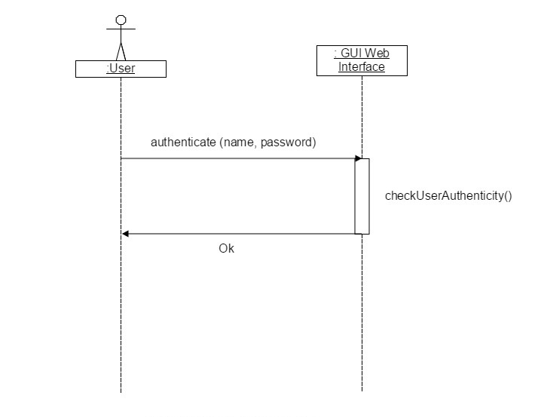

*Fig. 6.8. Sequence diagram for Use Case1: Login*

At the same time the user logs in, a timer starts running which is used to invoke the poller every 30 minutes. The manager checks for any changes in the nodes by requesting information from each of the agents. Once it receives a response from the agents, it updates the changes into a database.

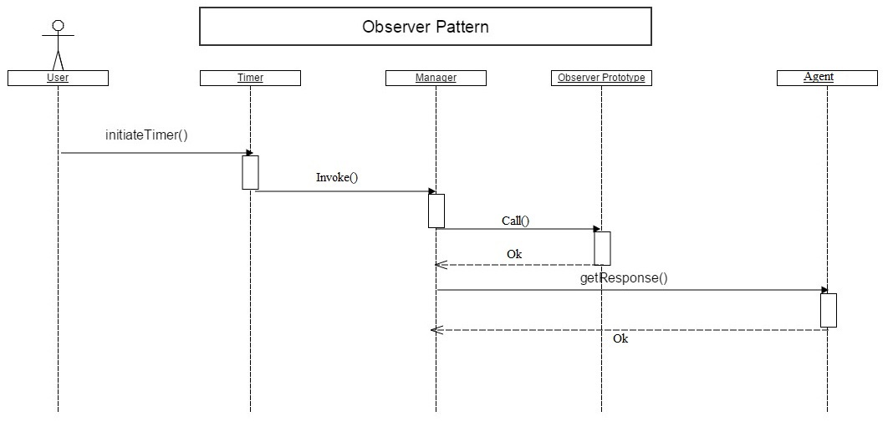

*Fig. 6.9. Sequence Diagram for Use Case 2: Initiate Timer*

The fourth Sequence diagram represents the fourth Use Case where the manager simply requests information from the CAB table and the CAM table in return send the required information as asked by the manager.

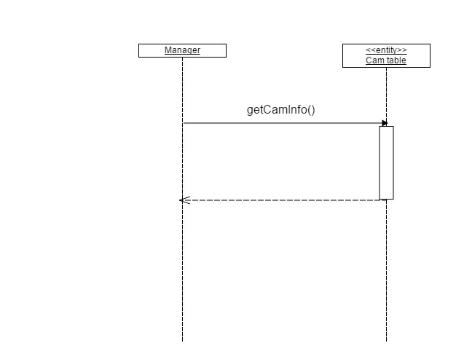

*Fig. 6.10. Sequence Diagram for Use Case 4: get Information from Switch CAM table*

Next, the manager converts the MAC address to IP address as shown in the sequence diagram below.

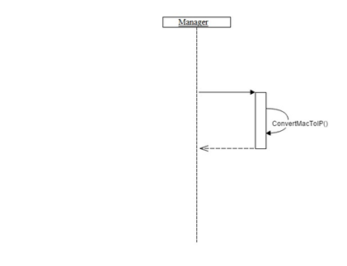

*Fig. 6.11. Sequence Diagram for Use Case 5: Map MAC to IP*

In the final step, the manager converts the data obtained from the CAM tables to information on each of the nodes. This useful information is sent to the database for updation.

Whenever a user successfully logs into the system and requests information on the status of any of the nodes, it is retrieved from the database and displayed on the Graphic user interface, in this case, a website.

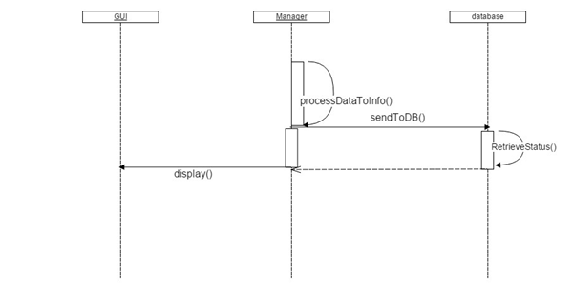

*Fig. 6.12. Sequence Diagram for Use Case 6: Process data to info and store in DB*

The next sequence diagram comprises of all the use cases mentioned and shows the sequence of operations of the system as a whole.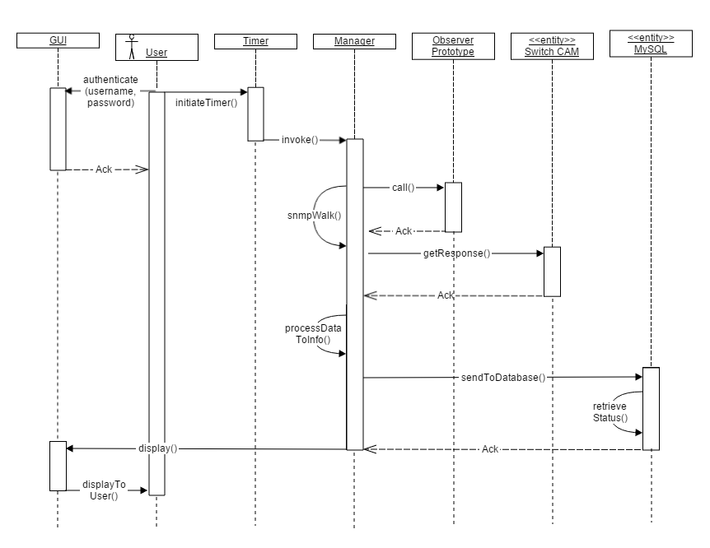

*Fig. 6.13. Complete Sequence Diagram*

**6.4.5 Dataflow Diagram**

A Data Flow Diagram (DFD) is a graphical representation of the "flow" of data through an [information system](http://en.wikipedia.org/wiki/Information_system), modeling its process aspects. A DFD is often used as a preliminary step to create an overview of the system, which can later be elaborated. DFDs can also be used for the [visualization](http://en.wikipedia.org/wiki/Data_visualization) of [data processing](http://en.wikipedia.org/wiki/Data_processing) (structured design).

At its simplest, a data flow diagram looks at how data flows through a system. It concerns things like where the data will come from and go to as well as where it will be stored. But information about the processing timing (e.g. whether the processes happen in sequence or in parallel) will not be found.

It is usually begun with drawing a context diagram, a simple representation of the whole system. To elaborate further from that, level 1 diagram are drawn with additional information about the major functions of the system. This could continue to evolve to become a level 2 diagram when further analysis is required. Progression to level 3, 4 and so on is possible but anything beyond level 3 is not very common. The level of detail asked for depends on the process change plan.

**6.4.5.1 Level 0**

Level 0 of the dataflow diagram represents how the user interacts with the system and also how the details are stored in the database.

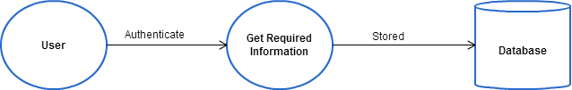

*Fig. 6.14. Level 0 Dataflow Diagram*

**6.4.5.2 Level 1**

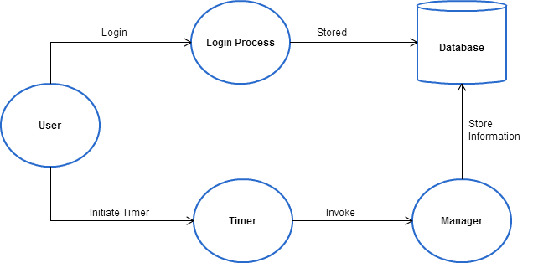

*Fig. 6.15. Level 1 Dataflow Diagram*

Level 1 gives a deeper insight into the system. As shown, once the user logs in, two events occur – the timer begins and the user logs in to retrieve information from the database. In the former case, the poller is invoked which in turn alerts the manager to update the database if there are any changes in the status of the nodes.

**6.4.5.3 Level 2**

Level 2 of the dataflow diagram shows how the manager operates on the information retrieved.

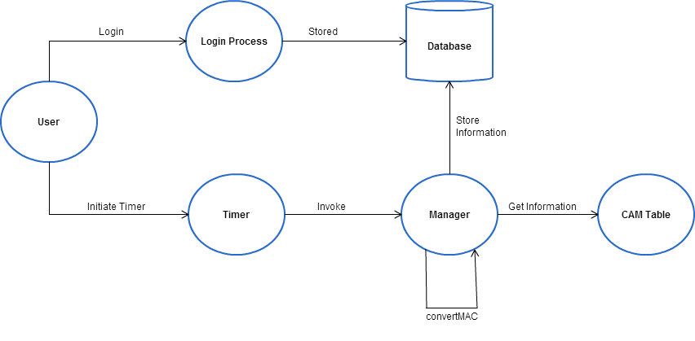

*Fig. 6.16. Level 2 Dataflow Diagram*

Once the poller calls the manager, CAM Table information is retrieved and is converted to useful information. This data is then stored in the database. This process occurs every 30 minutes i.e. whenever polling occurs.

**6.4.6 Class Diagram**

In software engineering, a class diagram is a type of static structure diagram that describes the structure of a system by showing the system's classes, their attributes, operations (or methods), and the relationships among objects.

In the diagram, classes are represented with boxes which contain three parts:

* The top part contains the name of the class. It is printed in bold and centered, and the first letter is capitalized.
* The middle part contains the attributes of the class. They are left-aligned and the first letter is lowercase.
* The bottom part contains the methods the class can execute. They are also left-aligned and the first letter is lowercase.

In the design of a system, a number of classes are identified and grouped together in a class diagram which helps to determine the static relations between those objects. With detailed modelling, the classes of the conceptual design are often split into a number of subclasses.

*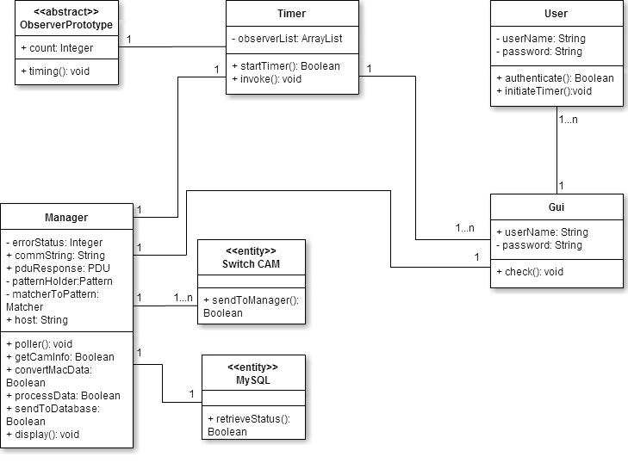Fig. 6.17. Class Diagram*

**6.4.7 Entity Relationship Diagram**

Also called an entity-relationship (ER) diagram, a graphical representation of entities and their relationships to each other, typically used in computing in regard to the organization of data within databases or information systems. An entity is a piece of data-an object or concept about which data is stored.

An entity–relationship model is a systematic way of describing and defining a business process. Entities may have various properties (attributes) that characterize them. Diagrams created to represent these entities, attributes, and relationships graphically are called entity–relationship diagrams.

A real-world thing either animate or inanimate that can be easily identifiable and distinguishable. For example, in a school database, student, teachers, class and course offered can be considered as entities. All entities have some attributes or properties that give them their identity.

The ER Model as shown below contains three entities VLAN Info, Switch Info, CAM table and User. Each of these has its own set of unique attributes. They are related by three relations Uses, Uses and Accesses.

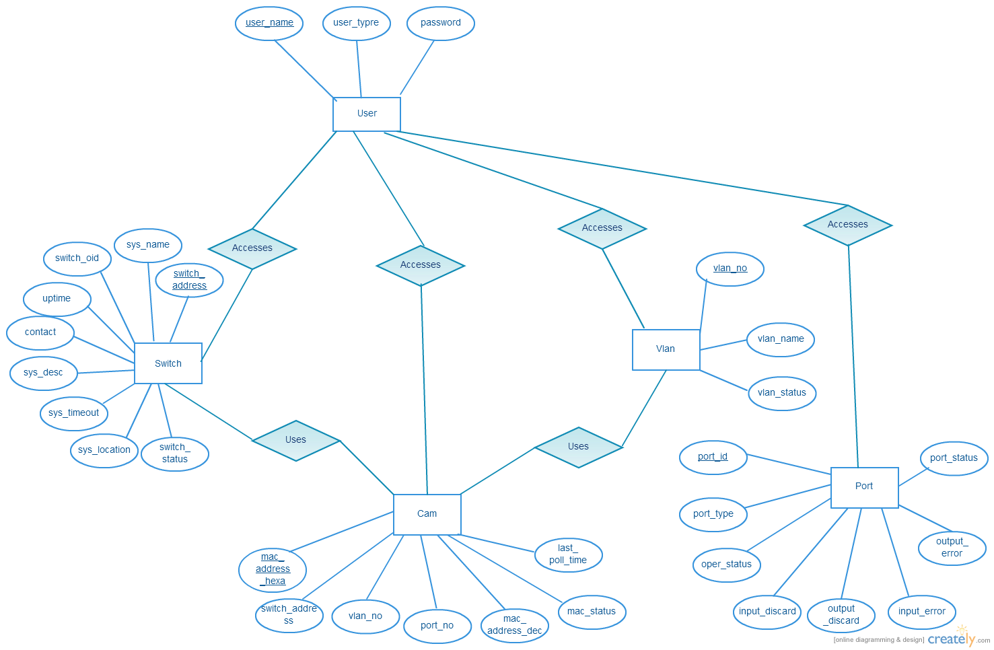

*Fig. 6.18. ER Model*

**Summary**

Software design is the process of implementing software solutions to one or more set of problems. Starting from the Use-Case to the ER-Model all the software designs have been put through rigorous verification procedures. Emphasis has been laid on planning, time schedules, target dates, budgets and implementation of an entire system at one time. Using these design templates the entire system has been developed further.

**Chapter 7**

**IMPLEMENTATION**

Implementation is the phase of transforming the design to working system. An implementation is a realization of a technical specification or algorithm as a program through computer programming and deployment. The implementation phase deals with issues of quality, performance, baselines, libraries, and debugging. Implementation provides a way to execute the program on one or more configurations of hardware and software. In computer science, an implementation is the realization of technical specification or algorithm as a program, software component, or other computer system through computer programming and deployment.

The implementation phase constraints the construction of the system requiring the following considerations:

* Implementation languages
* Resource limits
* Operation environments

**7.1 Modules for Implementation**

The modules that are used are divided into the Struts II Architecture system that is in terms of the Model, View and Controller. Within each there is a subdivision which corresponds to a subroutine within the module.

**7.1.1 Model**

The model is responsible for managing the data of the application. It responds to the request from the view and it also responds to instructions from the controller to update itself.

**7.1.1.1 Action Class for Login**

The Action class contains the business logic in the application. When form data is received, it is the execute method of an Action object that processes the data and determines which view to forward the processed data to. The Action class responds to a user action when user clicks a URL. One or more of the Action class's methods are executed and a String result is returned. Based on the value of the result, a specific JSP page is rendered.

Here the Action class comprises of the Login page where the user logs into the system. It is designed in JSP and displayed on the browser. If successful, a JSP page containing a webpage where the user has to display the MAC Address is shown.

The validation for this is done by accessing the database containing the login credentials of users and checks whether it is correct or not.

**7.1.1.2 Action class for Database Access**

An action class is created along with the MAC Address frame. This is done in order to access the database containing the data that has been polled. A validation occurs where the MAC Address is checked if it exists. If this is successful, the database retrieves the Port No, VLAN and other details associated with the MAC Address entered.

**7.1.2 View**

A view comprises of the presentation of data in a particular format, triggered by a controller's decision to present the data. They are script based template systems like JSP, ASP, PHP and very easy to integrate with AJAX technology. A JSP page is required to present the final message, this page will be called by Struts 2 framework when a predefined action will happen. Its mapping will be defined in struts.xml file.

Here the view comprises of a JSP page which is displayed as a frame along with the ‘Enter the MAC Address’ frame. It retrieves the data from the database and displays it to the user.

**7.1.2.1 Database Input and Output**

This section describes the input and output of the database that occurs. The data populated into the database is through a function known as SNMP Polling. This poller is initiated during the Login process and is continued every 30 minutes. During this mechanism, the various agents attached to the manager and their information is retrieved. This is converted to useful data and then stored in the database through JDBC. And it is retrieved using commands in Struts II. This is completed in Java programming language.

**7.1.3 Controller**

The controller is responsible for responding to user input and perform interactions on the data model objects. The controller receives the input, it validates the input and then performs the business operation that modifies the state of the data model.

This forms the cornerstone of the architecture where a FilterDispatcher class is created to control the flow of input and output to the browser. Here, it checks the input and determines which Action class needs to be called and what views have to be implemented to get the required output. Interceptors are optional parts of the Struts II Architecture that are not used or implemented in the system.

**7.1.4 Configuration Files**

In order to couple the Action, View and Controller such that the mapping of the functions is logical, configuration files are created and implemented. There are three configuration files that are essential. They are:

* struts.xml
* web.xml
* struts.properties

In struts.xml, the mapping tells the Struts 2 framework which class will respond to the user's action (the URL), which method of that class will be executed, and what view to render based on the String result that method returns.

The file web.xml is an entry point for any request to Struts 2. The entry point of Struts2 application will be a filter defined in deployment descriptor.

This configuration file provides a mechanism to change the default behavior of the framework. Actually all of the properties contained within the struts.properties configuration file can also be configured in the web.xml using the init parameter, as well using the constant tag in the struts.xml configuration file.

**Summary**

The implementation is done through Struts II which is an enterprise software that links all the parts of the system required to implement it. Using JSP, XML, HTML and Java languages, it coalesces the poller, database and web browser into one whole system. Its Architecture comprises of Model, View and Controller that enables separation and tying together of the parts of the system.

**Chapter 8**

**TESTING**

Testing is the process of evaluating a system or its components with the intent to find whether it satisfies the specified requirements or not. In simple words, testing is executing a system in order to identify any gaps, errors, or missing requirements in contrary to the actual requirements. According to ANSI/IEEE 1059 standard, testing can be defined as a process of analyzing a software item to detect the differences between existing and required conditions and to evaluate the features of the software item.

Testing is a practice of making objective judgments regarding the extent to which the system meets, exceeds or fails to meet stated objectives. It is an investigation conducted to provide stakeholders with information about the quality of the product or service under test. Software testing can also provide an objective, independent view of the [software](http://en.wikipedia.org/wiki/Software) to allow the business to appreciate and understand the risks of software implementation.

Testing process can be carried out by a software tester, software developer, project lead or an end user. Different companies have different designations for people who test the software on the basis of their experience and knowledge such as Software Tester, Software Quality Assurance Engineer, QA Analyst, etc. An early start to testing reduces the cost and time to rework and produce error-free software that is delivered to the client. However in Software Development Life Cycle (SDLC), testing can be started from the requirements gathering phase and continued till the deployment of the software.

**8.1 Levels of Testing**

Levels of testing include different methodologies that can be used while conducting software testing. The main levels of software testing are:

* Functional testing
* Non-functional testing

**8.1.1 Functional Testing**

Functional testing is a type of black-box testing that is based on the specifications of the software that is to be tested. The application is tested by providing input and then the results are examined that need to conform to the functionality it was intended for. Functional testing of a software is conducted on a complete, integrated system to evaluate the system's compliance with its specified requirements.

**8.1.1.1 Unit Testing**

Also known as component testing, involves testing the functionality of the software, usually at the function level. Each component/function is tested independently without other system components to ensure that they operate correctly. These may be functions or groups of methods collected together into a module or objects. These types of tests are usually written by developers as they work on code (white-box style), to ensure that the specific function is working as expected.

The goal of unit testing is to isolate each part of the program and show that individual parts are correct in terms of requirements and functionality.

*Table 8.1. List of Unit test cases*

|  |  |  |  |  |
| --- | --- | --- | --- | --- |
| **Sl. No** | **Case Description** | **Input** | **Pass/Fail** | **Comments** |
| 1 | Select Home Page | User Type implicitly taken from database | Pass | Admin/User success page reached |
| 2 | Navigation | User click on links | Pass | Working Fine |
| 3 | Display | Check Display format | Pass | Working Fine |
| 4 | Search Contents | Give MAC/Switch Details | Pass | Results displayed fine |
| 5 | Initialize Database | Implicit: Timeout | Pass | Database entries initialised to inactive |
| 6 | Resize Screen | Minimize/Maximize | Fail | Layout changed |

**8.1.1.2 Integration Testing**

Software components may be integrated in an iterative way or together. Normally the former is considered a better practice since it allows interface issues to be located more quickly and fixed.

Integration testing works to expose defects in the interfaces and interaction between integrated components. Progressively larger groups of tested software components corresponding to elements of the architectural design are integrated and tested until the software works as a system.

*Table 8.1. List of Integration test cases*

|  |  |  |  |  |
| --- | --- | --- | --- | --- |
| **Sl. No** | **Case Description** | **Input** | **Pass/Fail** | **Comments** |
| 1 | Timer Begin | Implicit: Successful Login | Pass | Timer Starts |
| 30mins after successful Login | Pass | Timeout Notification sent |
| 2 | Poll | Specific OID | Pass | Successful Community String Indexing |
|  |  | Trigger: Timeout | Pass | Polling |
| 3 | Data Transformation | OID raw Data | Pass | Regular Expression used before database population |
| 4 | Update Database | Trigger: Timeout | Pass | Update table entries to active |
| 6 | Poll Output | Request entry while polling | Fail | Previous Value used |
| 7 | Logout | Clicks Logout | Pass | Working Fine |
|  |  | Back Redirection | Fail | Previous Page reached |

**8.1.1.3 System Testing**

System testing test a completely integrated system to verify if it meets the requirements specified.  The software testing should ensure that the program does not also destroy or partially corrupt its operating environment or cause other processes within that environment to become inoperative. This type of testing is performed by a specialized team of testers.

System testing is important because of the following reasons:

* System testing is the first step in the Software Development Life Cycle, where the application is tested as a whole.
* The application is tested thoroughly to verify that it meets the functional and technical specifications.
* The application is tested in an environment that is very close to the production environment where the application will be deployed.
* System testing enables us to test, verify, and validate both the business requirements as well as the application architecture.

*Table 8.1. List of System test cases*

|  |  |  |  |  |
| --- | --- | --- | --- | --- |
| **Sl. No** | **Case Description** | **Input** | **Pass/Fail** | **Comments** |
| 1 | User Login | Valid username and valid password | Pass | Successful Login |
| Invalid username and invalid password | Pass | Error: Invalid Entries |
| Only username | Pass | Error requesting password |
| Only password | Pass | Error requesting username |
| Invalid username and valid password | Pass | Error: Invalid Entries |
| Valid username and invalid password | Pass | Error: Invalid Entries |
| Login redirection entered as URL | Fail | Success page reached when URL entered directly |
|  |  | Valid MAC Address | Pass | Working Fine |
|  |  | Invalid MAC Address | Pass | Error Message |
|  |  | Valid VLAN No. | Pass | Working Fine |
| 2 | Search Entries | Invalid VLAN No. | Pass | Error Message |
|  |  | Valid Switch ID | Pass | Working Fine |
|  |  | Invalid Switch ID | Pass | Error Message |
|  |  | Valid Port No. | Pass | Working Fine |
|  |  | Invalid Port No. | Pass | Error Message |
| 3 | Page Refresh | Renter Search entry(Without refresh) | Fail | Needs Improvement |
|  |  | Renter Search entry(With refresh) | Pass | Refreshed Page |
| 4 | Add User(Admin) | New username and password | Pass | Working Fine |
| 5 | Change Password | Current and New Password | Pass | Working Fine |
| 6 | Maximum Entries while Database Update | Population of data | Fail | Not Tested |
| 7 | Page Refresh | Renter Search entry(Without refresh) | Fail | Needs Improvement |
|  |  | Renter Search entry(With refresh) | Pass | Refreshed Page |

**8.1.1.4 Regression Testing**

Regression testing focuses on finding defects after a major code change has occurred. Specifically, it seeks to uncover [software regressions](http://en.wikipedia.org/wiki/Software_regression), as degraded or lost features, including old bugs that have come back. Such regressions occur whenever software functionality that was previously working, correctly, stops working as intended.

Typically, regressions occur as an [unintended consequence](http://en.wikipedia.org/wiki/Unintended_consequence) of program changes, when the newly developed part of the software collides with the previously existing code. Common methods of regression testing include re-running previous sets of test-cases and checking whether previously fixed faults have re-emerged.

**8.1.1.5 Acceptance Testing**

Acceptance testing is the most important type of testing, as it is conducted by the Quality Assurance Team who will gauge whether the application meets the intended specifications and satisfies the client’s requirement. The QA team will have a set of pre-written scenarios and test cases that will be used to test the application.

More ideas will be shared about the application and more tests can be performed on it to gauge its accuracy and the reasons why the project was initiated. Acceptance tests are not only intended to point out simple spelling mistakes, cosmetic errors, or interface gaps, but also to point out any bugs in the application that will result in system crashes or major errors in the application.

By performing acceptance tests on an application, the testing team will deduce how the application will perform in production. There are also legal and contractual requirements for acceptance of the system.

**8.1.1.6 Alpha Testing**

Alpha testing is simulated or actual operational testing by potential users/customers or an independent test team at the developers' site. Alpha testing is often employed for off-the-shelf software as a form of internal acceptance testing, before the software goes to beta testing.

**8.1.1.7 Beta Testing**

Beta testing is also called a pre-release testing. It is a form of external [user acceptance testing](http://en.wikipedia.org/wiki/User_acceptance_testing). Versions of the software, known as [beta versions](http://en.wikipedia.org/wiki/Beta_version), are released to a limited audience outside of the programming team known as beta testers. The software is released to groups of people so that further testing can ensure the product has few faults or [bugs](http://en.wikipedia.org/wiki/Computer_bug).

**8.1.2 Non-Functional Testing**

Non-functional testing involves testing a software from the requirements which are nonfunctional in nature but important such as performance, security, user interface, etc.

**8.1.2.1 Performance Testing**

It is mostly used to identify any bottlenecks or performance issues rather than finding bugs in a software. The different causes that contribute in lowering the performance of a software are network delay, client-side processing, database transaction processing, load balancing between servers, data rendering etc.

**8.1.2.2 Usability Testing**

Usability testing is a black-box technique and is used to identify any errors and improvements in the software by observing the users through their usage and operation. It can be defined in terms of five factors, i.e. efficiency of use, learn-ability, memory-ability, errors/safety, and satisfaction.

[Usability testing](http://en.wikipedia.org/wiki/Usability_testing) is also to check if the user interface is easy to use and understand. It is concerned mainly with the use of the application.

* + - 1. **Security Testing**

Security testing involves testing a software in order to identify any flaws and gaps from security and vulnerability point of view. It should ensure that the software possesses confidentiality, integrity, authentication, availability, authorization, non-repudiation etc.

**Summary**

Testing is an important phase before final implementation of a project. It provides assurance to the consumer and an overview on the limitations of operating the system. All three forms of testing- Unit, Integration and System testing has been performed on the system at different levels of the project development. It will not fail to meet any of the stated objectives during normal operation. It has also been tested with a few extreme conditions for quality assurance.

**Chapter 9**

**RESULTS AND PERFORMANCE EVALUATION**

A result (also called upshot) is the final consequence of a sequence of actions or events expressed qualitatively or quantitatively. The results of a project show the final outcome of the project.

**9.1. Polling Results**

The Polling action is the foundation for the working of the system. The Polling is divided into two parts:

* Initial Polling
* Subsequent Polling

The purpose of each of the polling actions is for specific purposes. The system initially has populated no contents into the database as shown below.

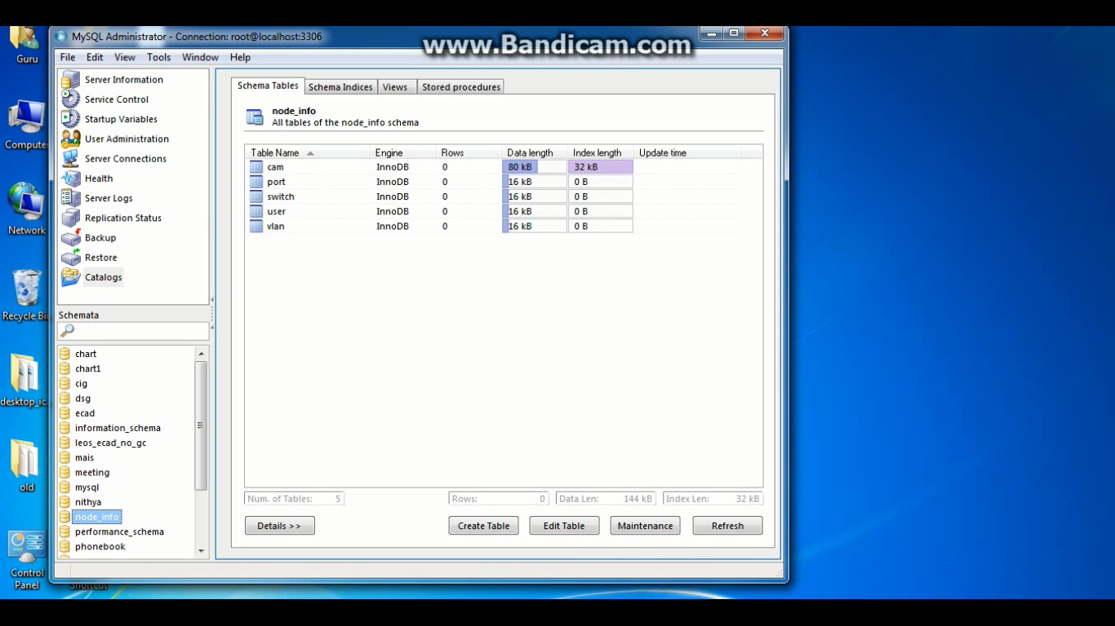

*Fig. 9.1 Initial Contents of Database*

Hence the initial polling fills the initial data and subsequent polls update this initial data that is already present. This is done to get the dynamic status of the nodes being discovered in the system.

**9.1.1 Initial Polling**

The initial polling is done by an independent program called ManagerNoTimer.java. Since this is to get the initial contents, it is not ruled by a timer. This program populates data into the database where all the entries are considered to be inactive nodes. Hence this cannot be used to show the status of nodes to the end user as it would be inaccurate.

However, it is necessary to get initial contents in the database.

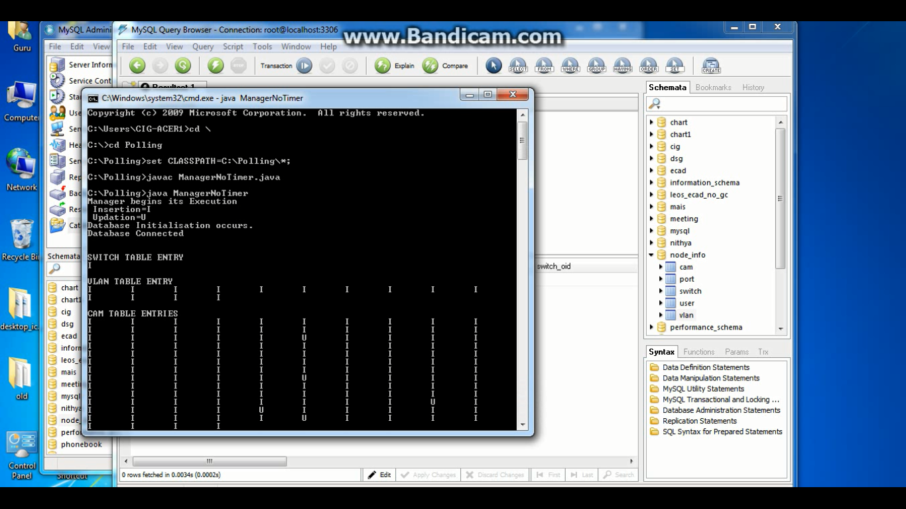

*Fig. 9.2. Execution of ManagerNoTimer.java*

As seen before, the contents of the database was empty. After this initial polling action, the contents of each table is shown below.

The tables in the database are:

* CAM Table
* Port Table
* Switch Table
* VLAN Table

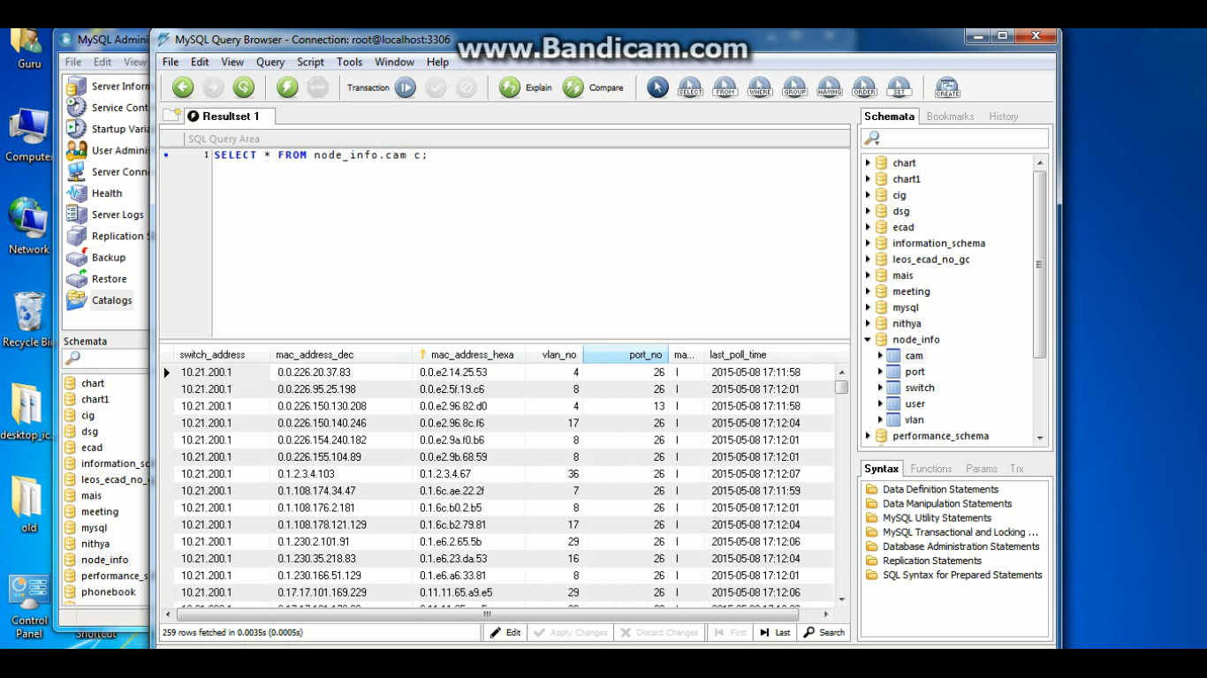

*Fig. 9.3 Initial Contents of CAM Table*

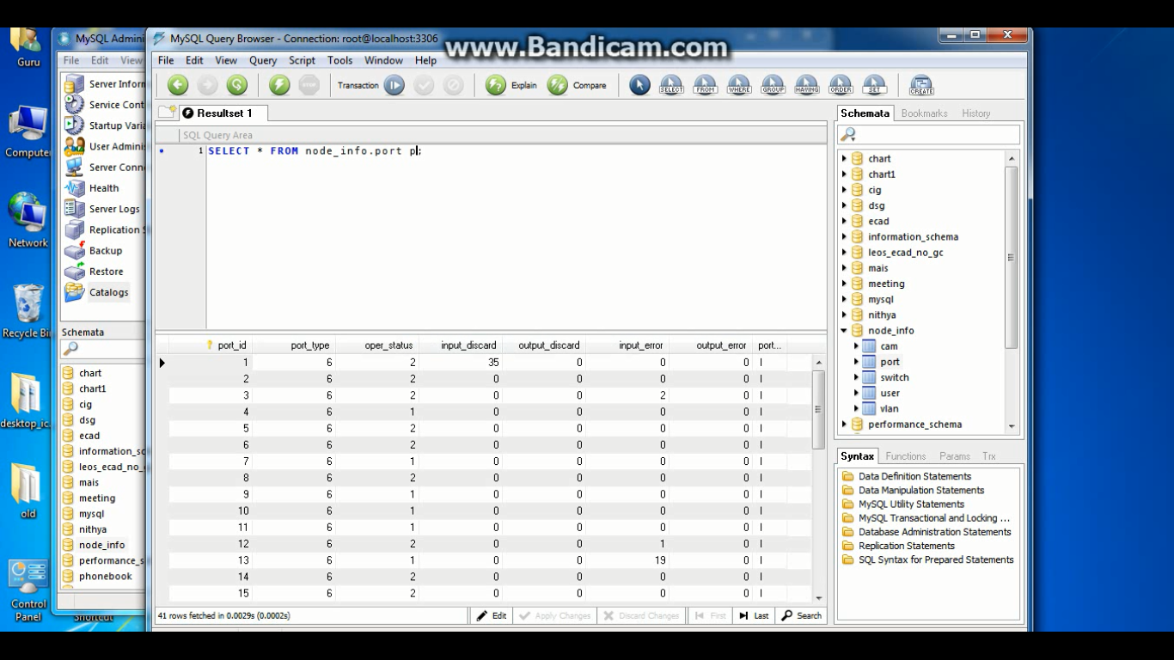

*Fig. 9.4. Initial Contents of Port Table*

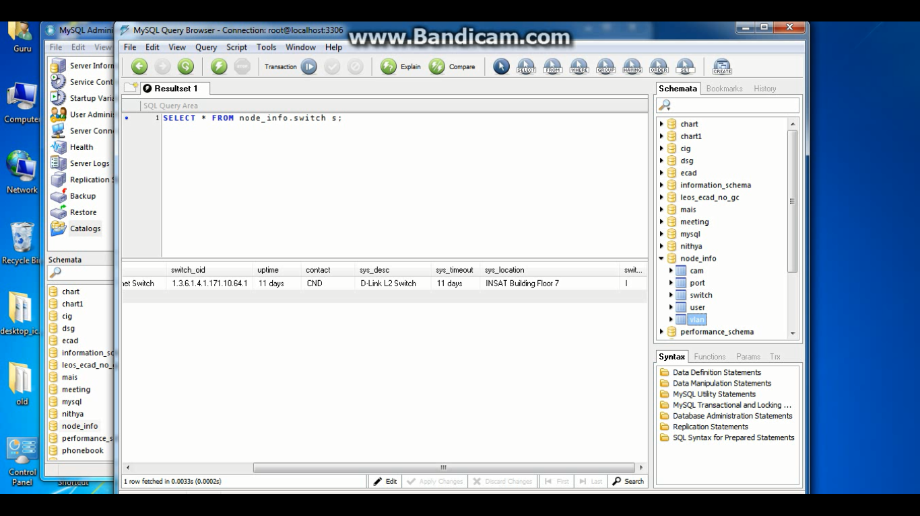

*Fig. 9.5. Initial Contents of Switch Table*

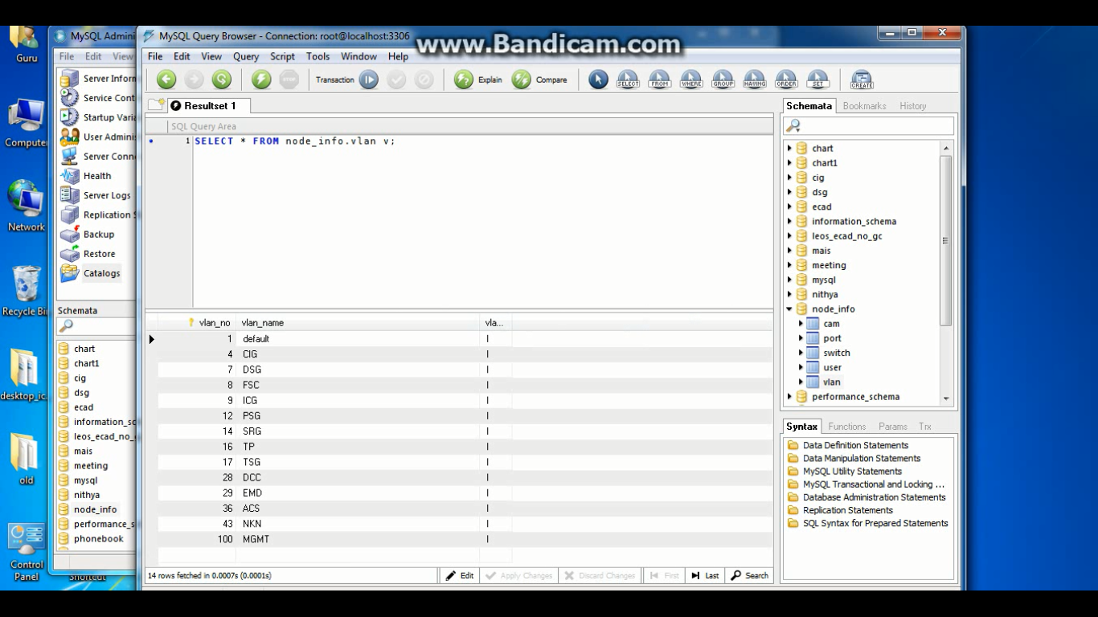

*Fig. 9.6 Initial Contents of VLAN Table*

**9.1.2 Subsequent Polling**

At this point, the database has contents in them and all the statuses are inactive. The second polling action which is considered to be identical to any subsequent poll is called by a program called Timer.java. According to the functional requirements of the system, the Timer calls for Polling every 30 minutes. However for the purposes of demonstration only goes up till 1 minute.

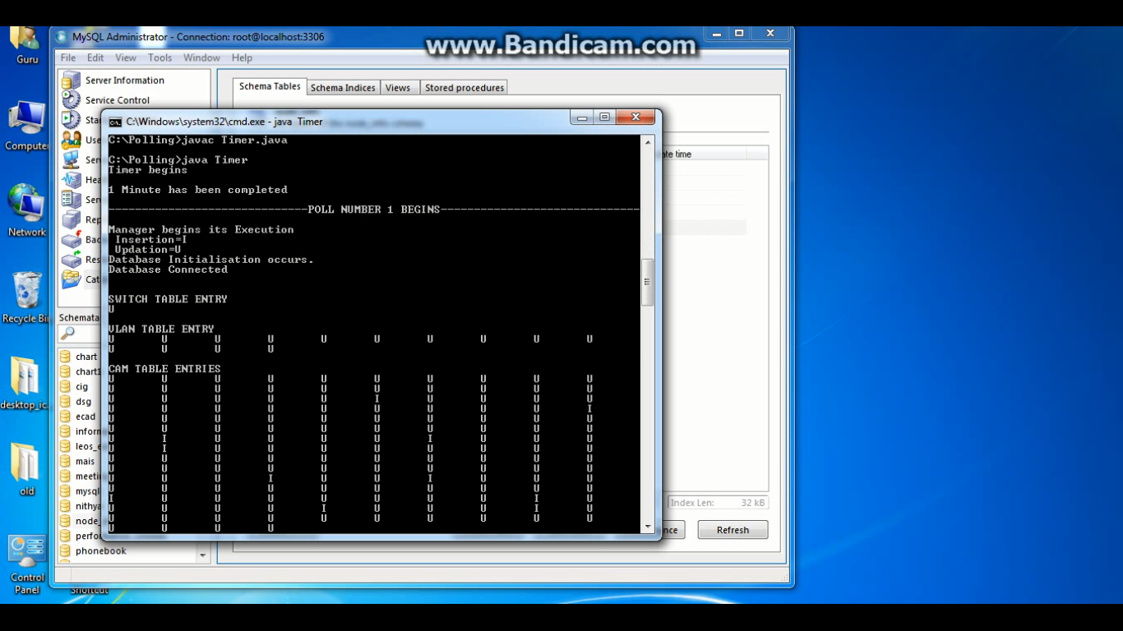

*Fig. 9.7. Timer.java Execution*

Hence, the Poller is called every minute. During each poll, if the node has been found in the initial database, the entry is changed to Active. If a node is not present in the database, then it is now inserted with an Active Status. This determines which nodes were inactive.

During each poll action, the database is fully initialized to inactive nodes and updation or insertion is done respectively. The contents of the tables are shown in the following diagrams.

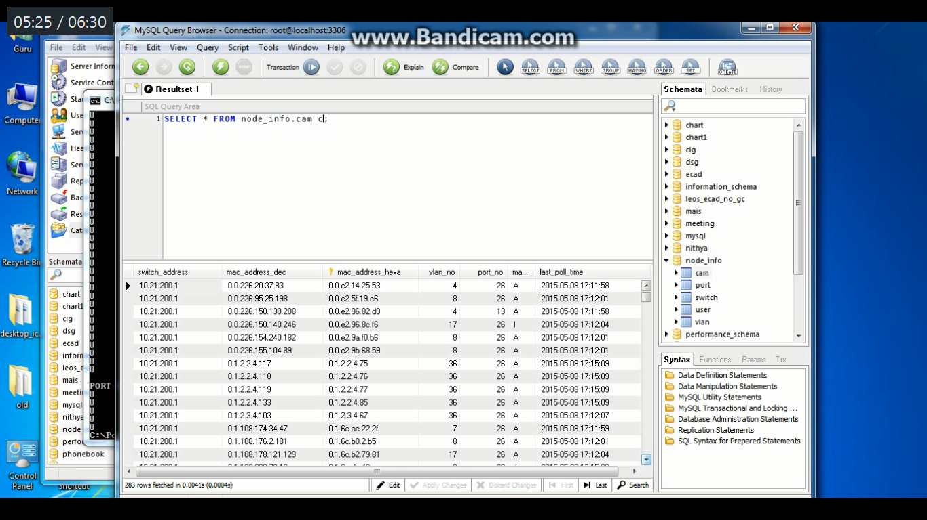

*Fig. 9.8. Subsequent Contents of CAM Table*

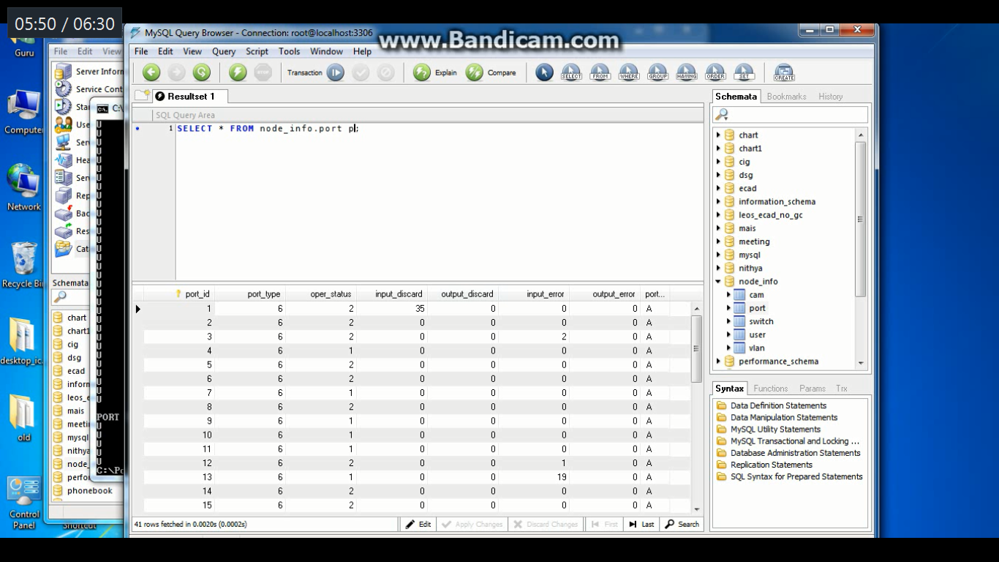

*Fig. 9.9. Subsequent Contents of Port Table*

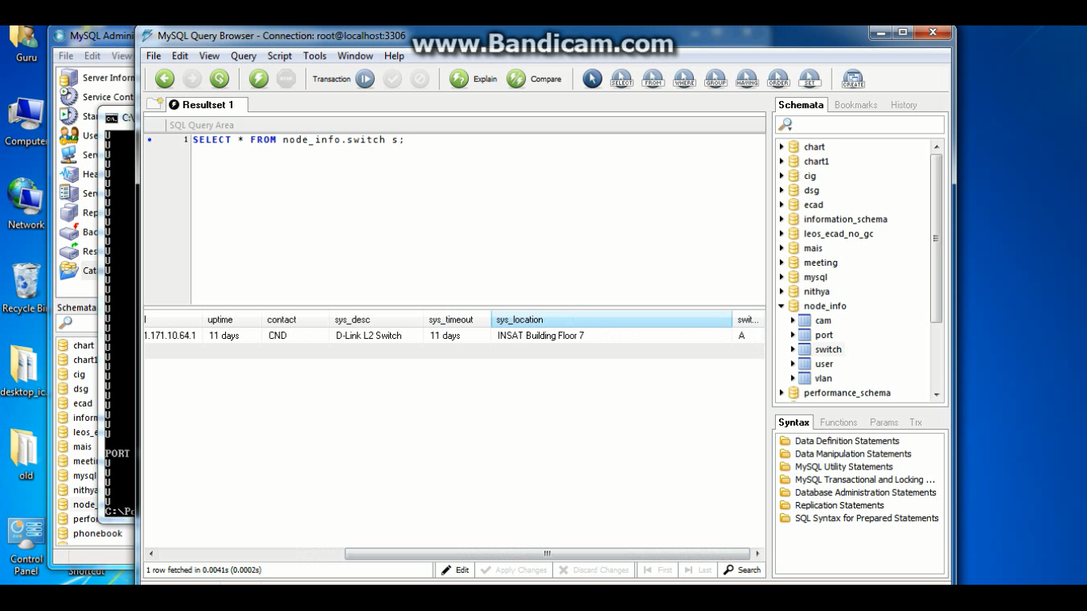

*Fig. 9.10. Subsequent Contents of Switch Table*

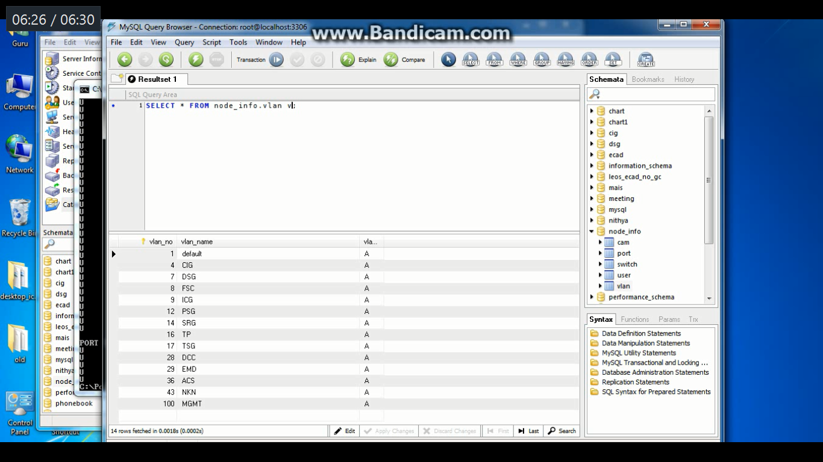

*Fig. 9.11. Subsequent Contents of Port Table*

**9.2 Website Display Results**

Now that all the data has been populated in the database, it is accessed by network administrators through a Login Portal. This is hosted currently on Apache Tomcat.

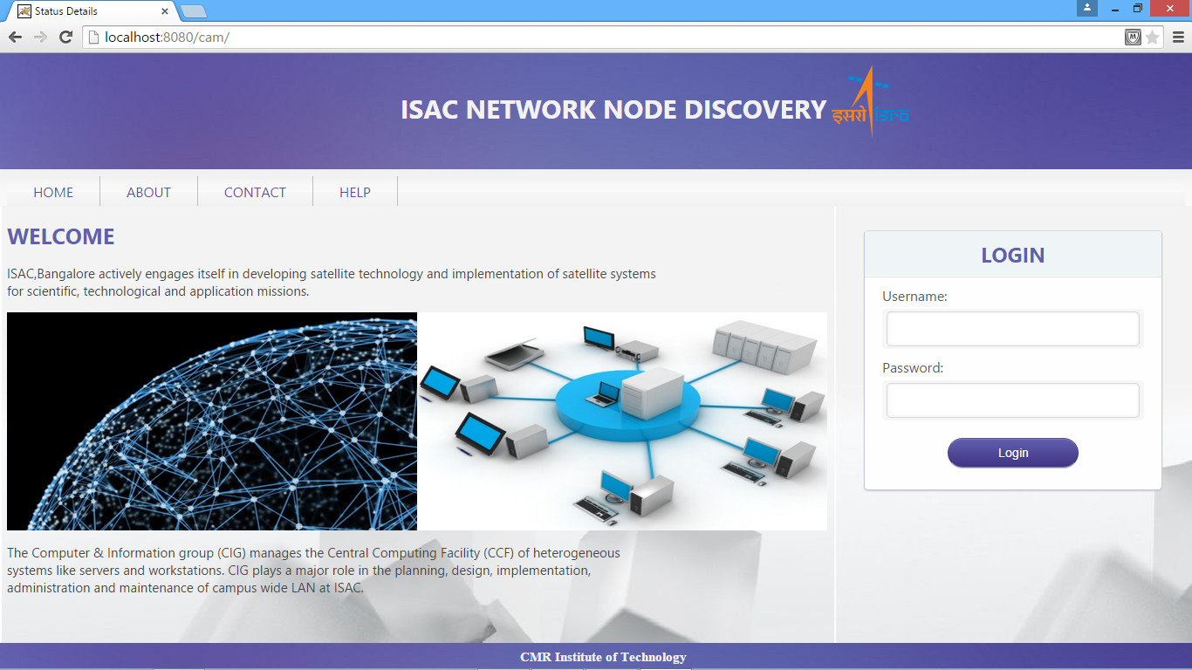

*Fig. 9.12. Home Page*

While the user tries to input, JQuery validation is done to make sure that the user enters both username and password. Otherwise, an error message is displayed.

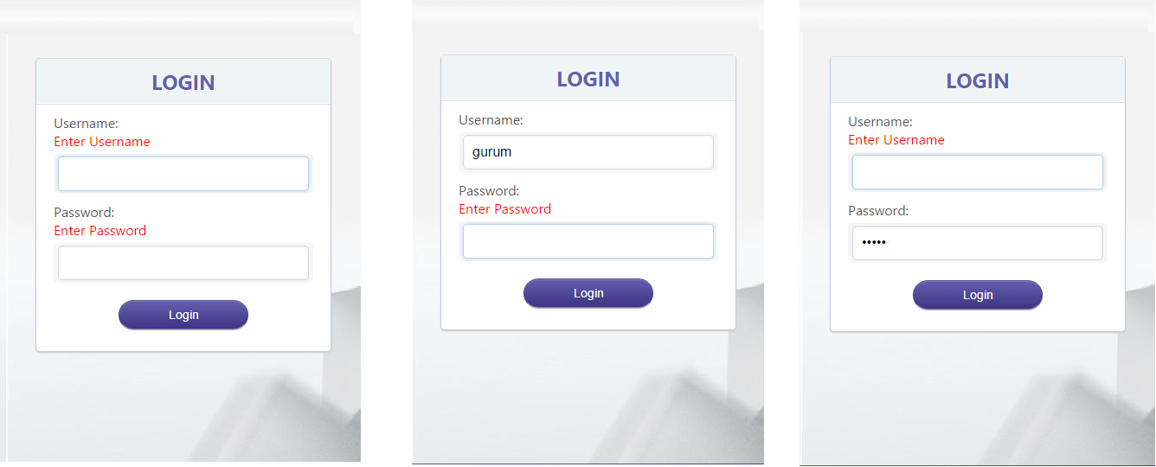

*Fig. 9.13. Error Messages for Login*

Once a successful Login occurs, the System determines whether the user is of type Administrator or a Normal User and accordingly displays the Success page showed below (for administrator).

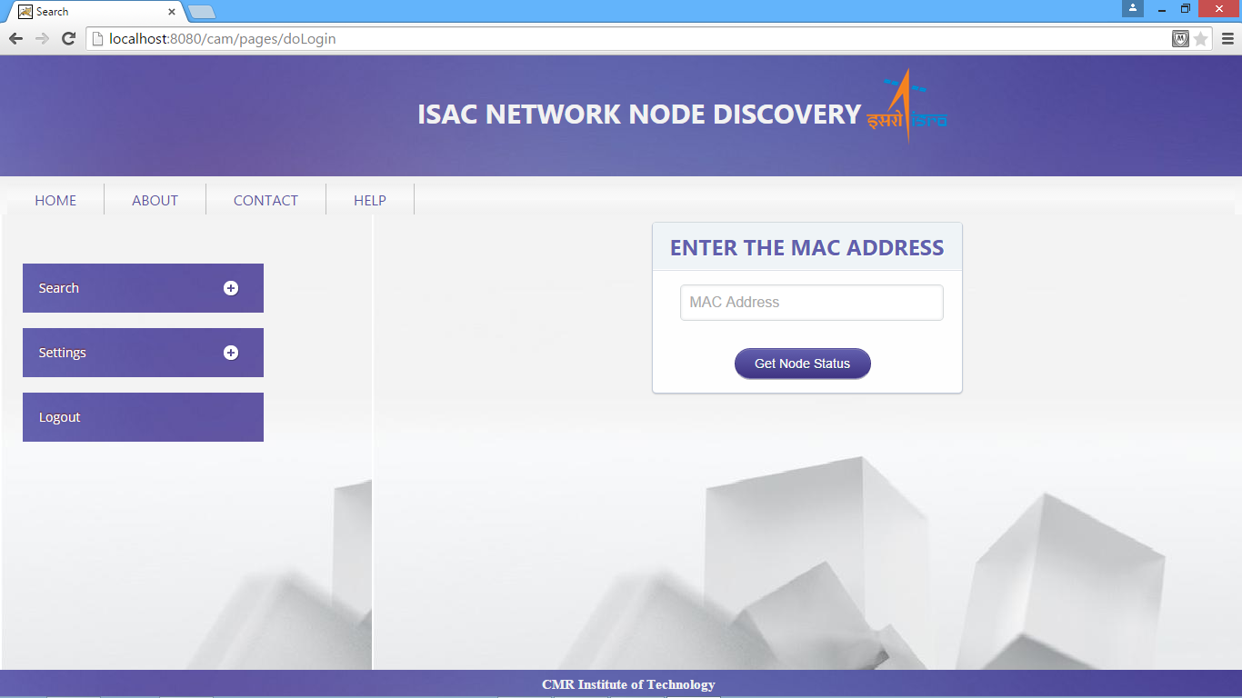

*Fig. 9.14. Administrator Success Page*

**9.2.1 MAC Results**

Using Struts II, the database which has been populated with data is attached to the website. Hence, appropriate querying occurs to find the requisite data.

Here, the MAC Address displaying is tied to the CAM Table in a database. This shows whether a certain node is active or inactive. If the MAC Address is invalid, an error message is shown.

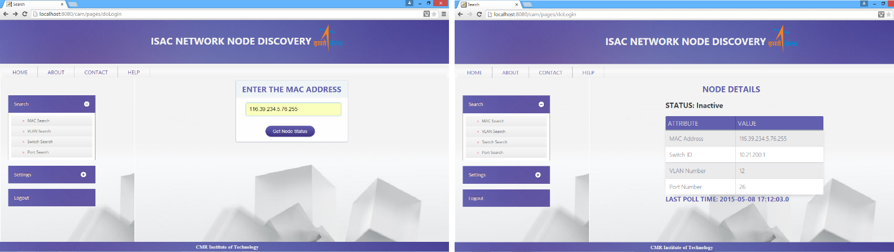

*Fig. 9.15. Inactive node in the network*

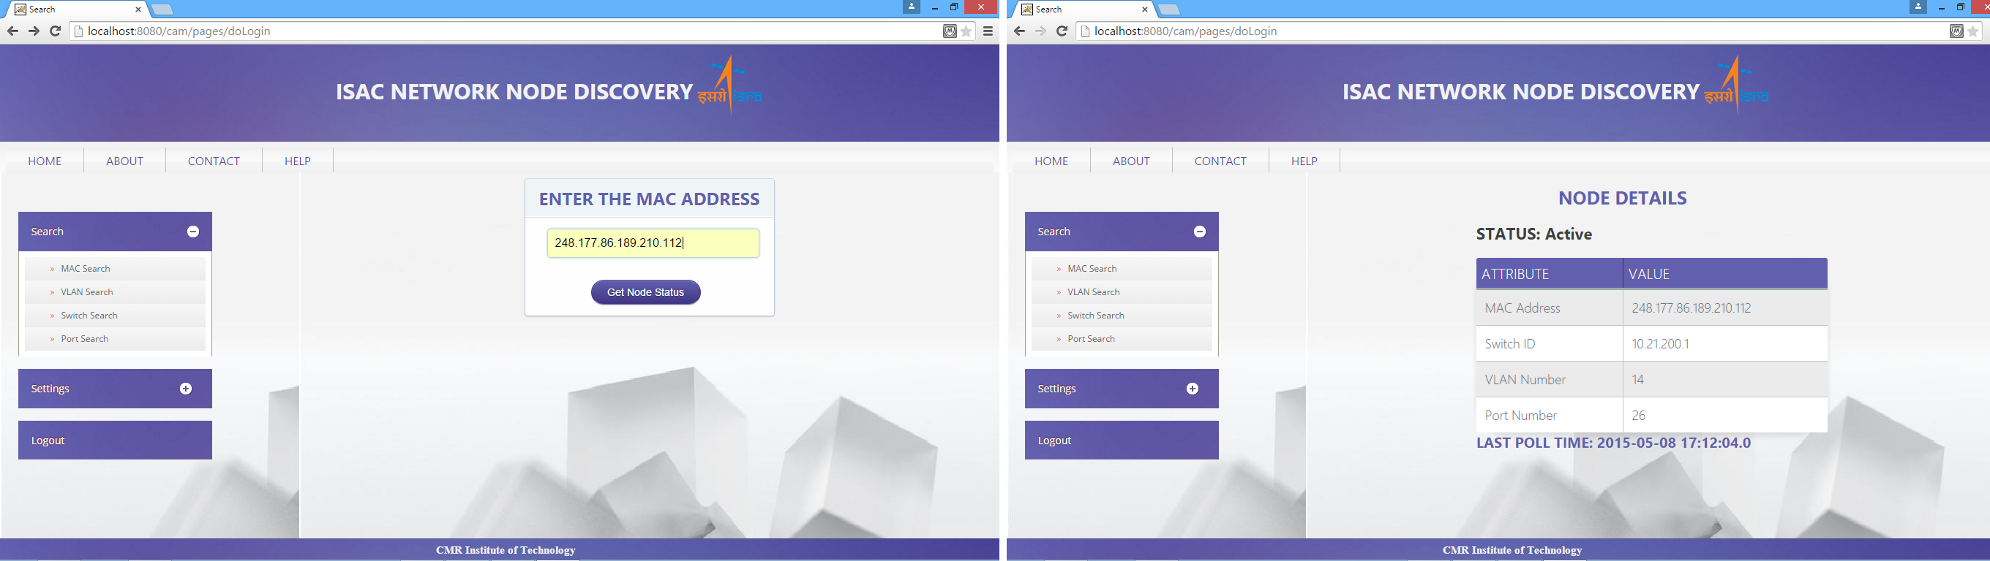

*Fig. 9.16. Active node in the network*

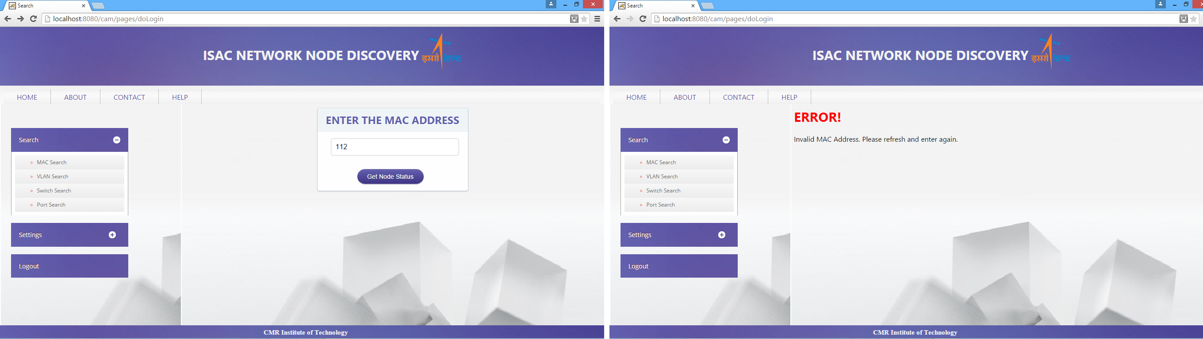

*Fig. 9.17. Invalid MAC Address entered*

**9.2.2 VLAN Result**

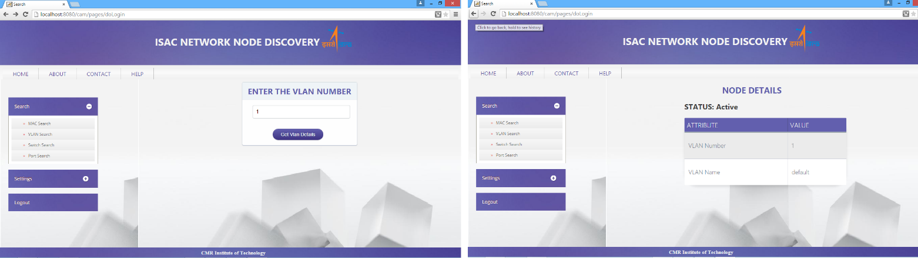

*Fig. 9.18. Active VLAN of network*

In the same manner, the VLAN Search part of the website is attached to the VLAN Table which has been populated with data related to it. Again, if the node is active, then the correct data is shown. If inactive, then the status is accordingly shown. If the VLAN is not found in the database, an error message is displayed.

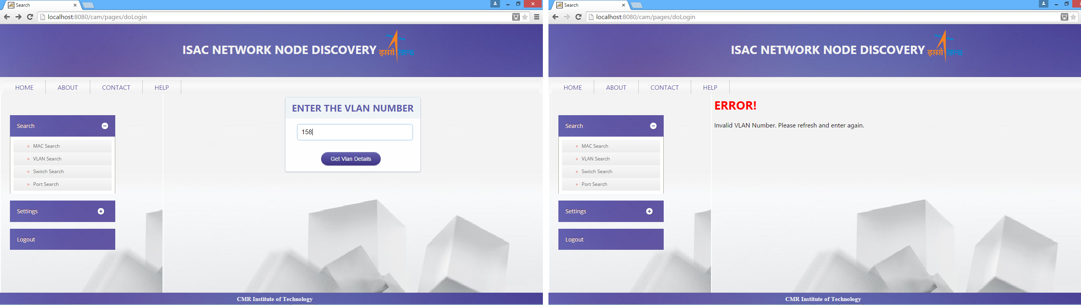

*Fig. 9.19. Invalid Input*

**9.2.3 Switch Result**

Next, the Switch Search part of the website is attached to the Switch Table which has been populated with data related to it. Again, if the node is active, then the correct data is shown. If inactive, then the status is accordingly shown. If the Switch is not found in the database, an error message is displayed.

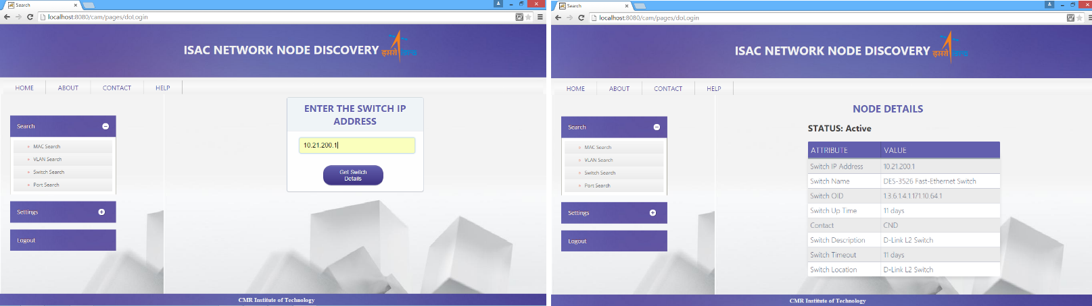

*Fig. 9.20. Active Switch of network*

**9.2.4 Port Result**

Lastly, the Port Search part of the website is attached to the Port Table which has been populated with data related to it. Again, if the node is active, then the correct data is shown. If inactive, then the status is accordingly shown. If the Port is not found in the database, an error message is displayed.

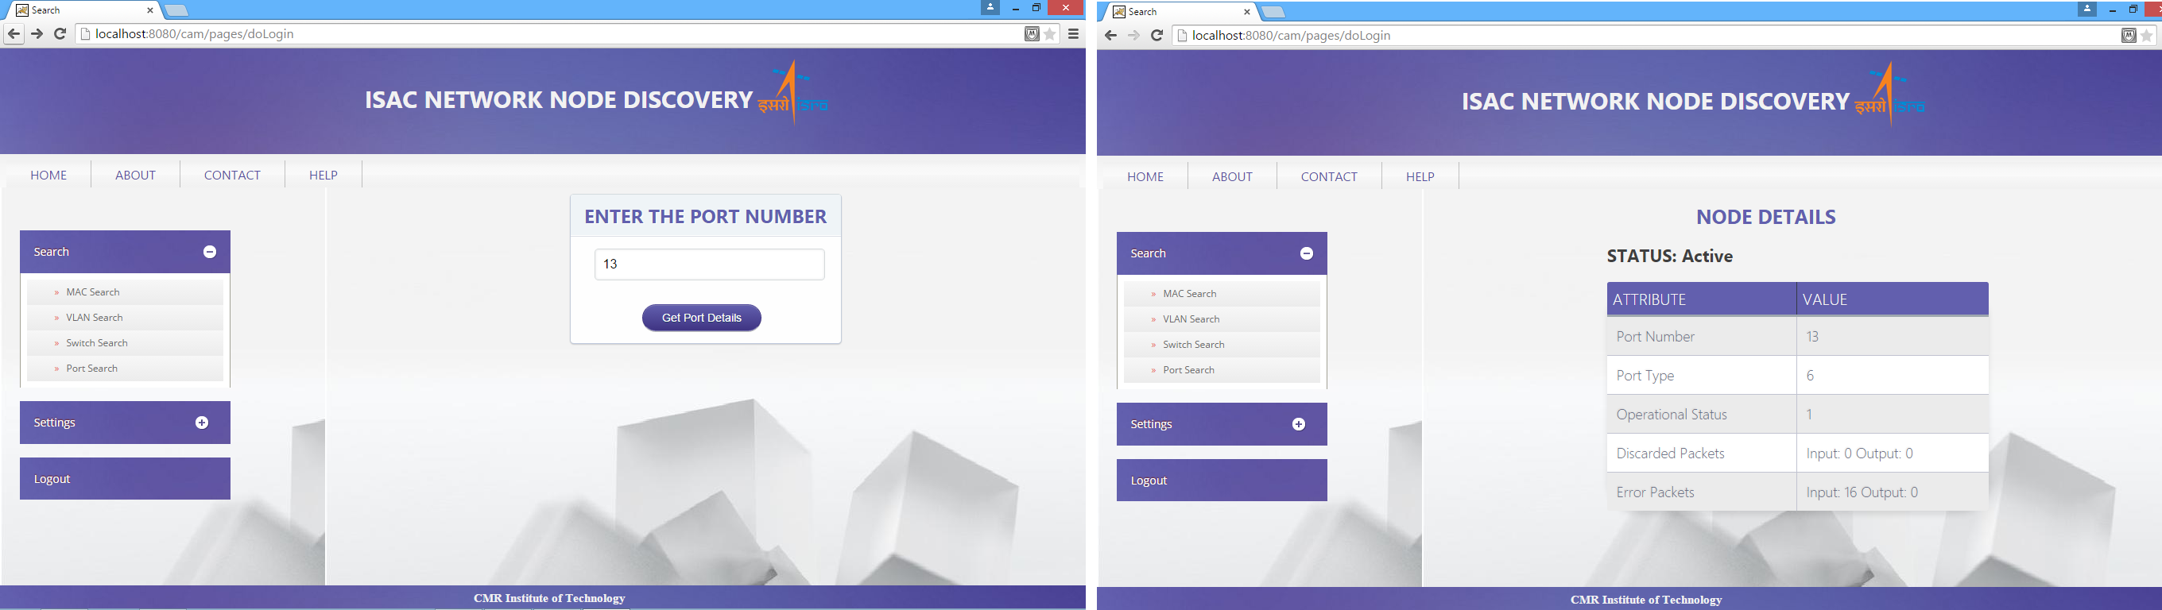

*Fig. 9.21. Active Port of network*

**Summary**

The system is divided into parts, the common entity being the MySQL database which is populated by the Poller part of the system and is accessed by the Website part of the system. The Poller itself has an initial Poll function and a subsequent Polling action which is controlled by a Timer that initiates Polling every 30 minutes. All this data is immediately populated into the database which is accessed by the Website using Struts II.

**Chapter 10**

**CONCLUSION AND FUTURE SCOPE**

The system that has been implemented offers elementary aid to network administrators in ISRO Satellite Centre to find nodes that are not connected to their respective ports and the reason behind it. Locating the faulty nodes and the cause of their failure increases the ease of finding problems in the network for network administrators.

The portability of the system that has been created along with the real time showcasing of the status of these nodes makes the work for network administrators easier. The usage of Struts has aided the management and maintenance of the website. It provides a unified framework for deploying servlet and JSP applications that use the MVC architecture. The advantage of MVC is that the user can concentrate on the UI alone while coding without worrying about the business logic.

The system can be used with ease because of its interactive UI. It can also be readily implemented in the ISRO Satellite Centre. The Network administrator who is given the ‘admin’ status can regularly check the status of each and every node attached to the network. He may add users and set the timer to update the database at his will.

All in all, this simple Network Management tool has features that suit the network of ISRO Satellite Centre and can be put to use immediately. It is specifically designed to work in the ISRO Satellite Centre. The various users may also log into the system to view the statuses of the nodes. If features like Topography Discovery, alert messages, etc. are added to it, then it would definitely improve maintain the network.

**10.1 Future Scope**

This system lays the foundation for several improvements that can be done to make finding the status of a node much easier. Firstly, the system can be expanded to L3 Switches which would be identified by their IP Addresses. Currently, the system recognizes only L2 switches. Traversing the L3 switches as well would increase the number of nodes reporting to the Network Administrator.

Along with this, the Graphical User Interface can be modified to show a live version of the network in a graphical form. Because of this, an administrator can find out the exact location or the precise cause of the failure of a node or the reason for the faultiness. Using the trap function of SNMP messages, alert messages can be sent to the network administrator from any of the nodes if required. These alert messages would help detect malfunctions within the network.

A node becomes inactive in a subsequent poll if it has not been traversed during SNMP Walk. In some cases this may occur when the node becomes faulty or is detached from the network. If the alert messages could also send the type of fault to the administrator, then it would be very convenient to rectify the error.

With these three features- L3 switch traversal, Graphical User Interface and alert messages- added to the Network Management Software, it would help notify the administrator about the status of a wider range of nodes in the network.